UKRAINIAN ORTHODOX CHURCH OF THE USA
CONSISTORY OFFICE OF PUBLIC RELATIONS
PRESS RELEASE
ANNUAL CLERGY CONFERENCE CONVENES - Day 2
St. Andrew Metropolia Center, South Bound Brook-Somerset, NJ –
site of the Clergy Conference – welcomes clergy from coast to coast.
Day two of the Clergy Conference featured an incredibly enriching – spiritually, intellectually, pastorally and emotionally – full-day presentation by Mr. Bill Marines – Attorney, Legal Consultant to the Assembly of Canonical Orthodox Bishops of the USA and motivational speaker concerning Stewardship in Orthodox parishes all over the USA and beyond. The title of the presentation was: “How can we Better Live our Callings and Improve our Lives, Parishes and Parishioners?”
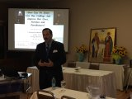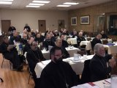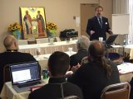

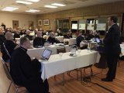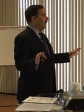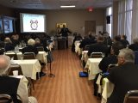

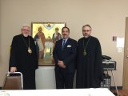

Bill challenged the clergy brotherhood to wake up and reset their lives and let this day be the one in which they make something happen. He offered a short video by Simon Sinek, which posed the questions: Why are we here and do what we do? What are we doing well/poorly and what should we be doing? How can we do better that which we need to do?
In the second part of the presentation a discussion concerned how the world has changed and what challenges priests are facing today. What is really going on in our parish communities? The meat of the Mr. Marines’ presentation came in section three of the program with a discussion about: What are the top parish challenges? What are the top laity challenges? What are the top clergy challenges? Utilizing the research efforts of Fr. Michal White and Tom Corcoran in a publication titled REBUILT, the responses to these questions from these three groups were the impetus for “Awakening the Faithful, Reaching the Lost and Making Church Matter”.
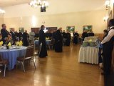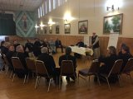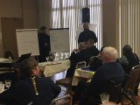

The brothers were divided into three break-out groups for discussion of the three areas above with regard to their parishes: parish challenges, laity challenges and clergy challenges. Upon return to the larger group one hour later, a spokesman from each group presented the challenges each groups faced and offered possible solutions to the challenges and the floor was opened for questions and challenges to the conclusions. It was a lively discussion but Mr. Marines “pushed back” on the groups seeking to understand why the groups had not begun their discussions with the question “Why?” Without first comprehending the why we are here and why we do what we do, we will never come to the proper conclusions in seeking resolutions to our challenges. The efforts of the discussion groups were not wrong in their challenges and conclusions, but they would have perhaps approached the whole effort from a different perspective if they had first considered the why.
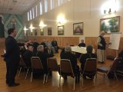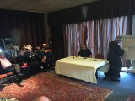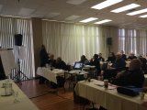

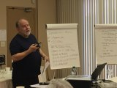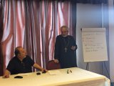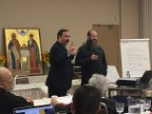

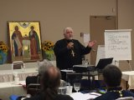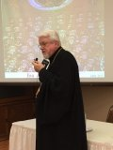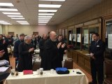

Mr. Marines praised the clergy for their response to the call of our Lord to His service, saying that he could never take on the responsibility of the salvation of souls as his life work because it seems to be a most extreme challenge. He urged the brothers to keep asking the why’s in their daily lives. He urged them to realize that they have been given the authority and the power to accomplish all they were called to. He urged them to be supportive of one another – to “have one another’s backs” along with the obvious support they have from their hierarchs. The brothers rose from their seats and gave a standing ovation to Bill in appreciation for the blessing of his presence among them for the day. They sang a traditional “Mnohaya Lita” for him wishing many more years to fulfill his “call” to serve the Lord.

