

**Igniting the Flame of Orthodoxy**

C:\STOCKLAYOUTS\CURRENT PROJECTS\FN99807-PL\FN99807-IMG03.emfC:\STOCKLAYOUTS\CURRENT PROJECTS\FN99807-PL\FN99807-IMG01.emfC:\STOCKLAYOUTS\CURRENT PROJECTS\FN99807-PL\FN99807-IMG05.emf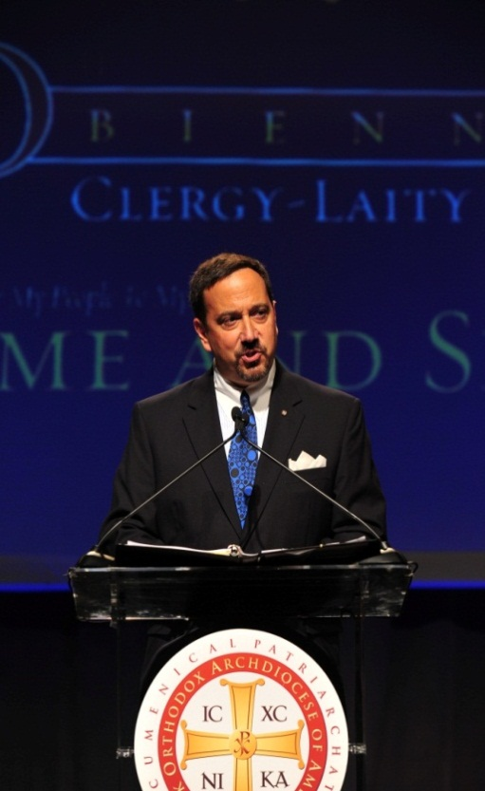

**Saturday, January 24, 2015**

**9:00 AM – 3:00 PM**

**(Breakfast and lunch will be provided.)**

**Christ The Savior**

**Greek Orthodox Church**

**🟇150 Elizabeth Ann Circle 🟇**

**🟇 Bluff City, TN 🟇**

**🟇(888) 537-0087🟇**

**Participants will learn:**

* **How to implement a Parish strategic plan?**
* **A new Parish operational paradigm**
* **3 critical stewardship principles**
* **2 dynamic stewardship tactics**
* **9 step process to reorganize your stewardship and fully engage your Parishioners**
* **3 effective communications strategies**

Learn how to completely **re-organize, re-energize** and **re-vitalize** your Parish and its stewardship and other ministries, Parish operational paradigm and how to live your personal stewardship calling. The Igniting The Flame program is a comprehensive approach to organize the most effective and strategic Parish and ministries. This new vision will break the chains that bind us to less effective practices and will maximize results of ministries and stewardship in our communities.

A Parish that develops a true strategic vision and plan and practices true Christian Stewardship is truly **on fire** and can **achieve the unimaginable**. Come learn how true Stewardship and strategic planning can transform and improve your parish.

**For questions, contact:**

**Bill Marianes**

**www.stewardshipcalling.com**

**Bill@stewardshipcalling.com**

***Much is required from the person to whom much is given; much more is required from the person to whom much more is given.* Luke 12:48**

