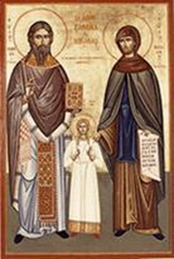
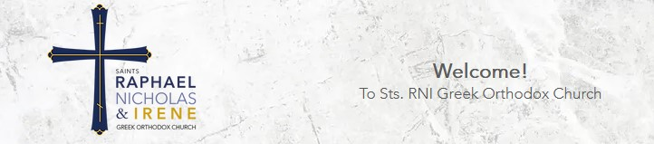
Saints Raphael, Nicholas & Irene Strategic Plan
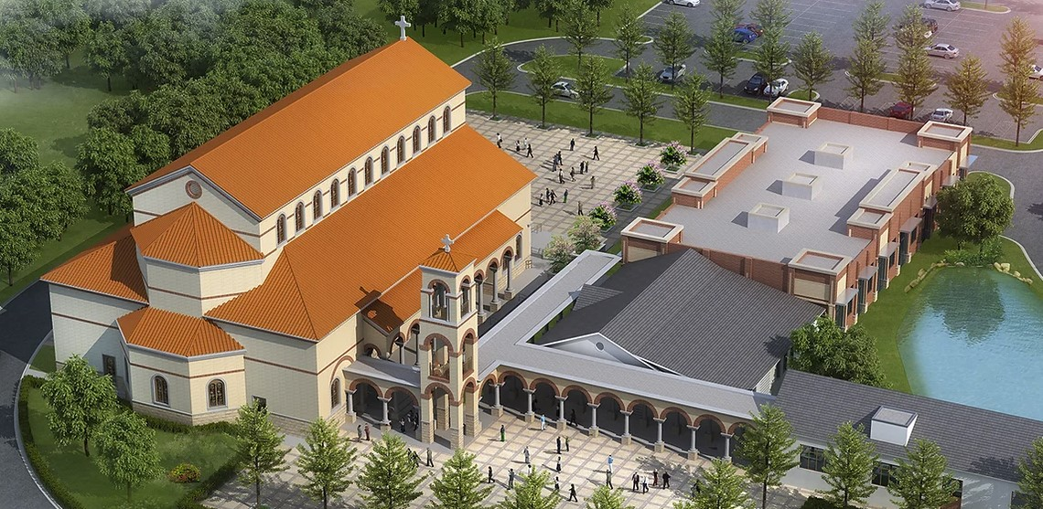

Beloved in Christ,

I like what Michael J. Fox once said, "I am careful not to confuse excellence with perfection. Excellence I can reach for. Perfection is God's business."

As we launch the Implementation Phase of our Strategic Plan, we will be tempted by perfection, but we must resist this "too easy" excuse! As "The Preacher" said in Ecclesiastes "Whatever your hand finds to do, do it with your might; for there is no work or device or knowledge or wisdom in the grave where you are going." (Ecclesiastes 9:10)

We are all called to "have the right answer before the awesome judgment seat of Christ," as Bill reminds us. And part of that "right answer" is making sure we pursue excellence in our parish ministries and outreach. Implementing the necessary improvements in our effective ministries will go a long way toward fulfilling our mission statement to be "a welcoming family who develops intentional Orthodox Christians through worship, education, outreach, and service."

Change isn't easy. If it were, we wouldn't fear it so much., So, don't lose heart when the road is difficult. Strive for excellence to "Be diligent to present yourself approved to God, a worker who does not need to be ashamed, rightly dividing the word of truth." 2 Timothy 2:15)

Let's embrace the adventure together, and together, we will see God grow us into an excellent parish committed to being transformed by God's grace.

Your Faithful Co-Laborer,
+Father Barnabas Powell

EXECUTIVE SUMMARY

Sts. RNI welcomes all on a transformational journey to a life of purpose and salvation.

Progress and success require periodically assessing where you are, where you want to be, and how you will get there. Our Sts. Raphael, Nicholas & Irene Parish is a pioneer in undertaking this systematic, ambitious, and exciting process. We focus on helping our faithful and creating the most robust and dynamic Parish. This comprehensive Strategic Plan will help all of us manage the “busyness” of our Parish without turning our Parish into a “business.” We will make history together as we implement this Strategic Plan to benefit our Parish, parishioners, and community.

For many months, approximately 25 dedicated lay stewards and our clergy, representing the significant diversity within our Parish, have worked joyfully and diligently to analyze available data and issues and develop this Strategic Plan by consensus with input from many of our faithful throughout our Parish. Through a disciplined process, we conducted a detailed analysis of the Strengths, Weaknesses, Opportunities, and Threats (S.W.O.T.) of our Parish and developed the following MISSION statement:

Sts. RNI is a welcoming family who develops intentional Orthodox Christians through worship, education, outreach, and service

We also carefully analyzed the behaviors we wanted to model in our Parish. We concluded that to drive our culture and priorities and provide a framework for decision-making, we will embrace the following shared CORE VALUES:

- Intentionally Orthodox
- Community
- Agape Love
- Christ-Focused

In determining what we hoped to accomplish and where we were going, we developed a dynamic and inspirational VISION that proclaims that:

Sts. RNI will:

(a) measurably improve our Adult and Youth Stewardship & Ministry Engagement and Religious Education Ministry within 36 months; and

(b) establish and Implement a Viable Building and Capital Campaign Strategy to Have a New Church within 54 months.

To address our Strengths, Weaknesses, Opportunities, and Threats, stay true to our Mission and Core Values, and pursue our Vision, we identified three major strategic areas of focus and organized a separate Task Force to identify and address goals in each area:

- Facilities & Building Campaign
- Stewardship & Engagement
- Adult & Youth Catechism

These 3 Task Forces then developed by consensus the Strategic Goals and the detailed action plans to achieve them, all of which met the “S.M.A.R.T.” goal criteria of being Specific, Measurable, Attainable, Relevant (and Realistically written), and with achievable Timetable.
Our Strategic Plan that follows this Executive Summary is in three distinct parts:
Part 1 (pages 2 through 12) includes more detail about the process, the team, our Statement of Why, and our S.W.O.T. Analysis, Core Values, Mission, and Vision.
Part 2 (pages 13 through 29) lays out the three specific S.M.A.R.T. Goals and the very methodical, step-by-step implementation action plan and process to achieve each goal, including precise timelines, areas of responsibility, and how we will measure success.
The length of this Strategic Plan may give some pause. However, given the vast diversity of our Parish, faithful, and our needs, we wanted to provide a thorough analysis of what we must do and a comprehensive plan to accomplish everything in a unified and effective manner. We ensured that our Parish, Parish-level ministries, and parishioners were the primary focus of every aspect of our planning.

The real work begins as we commit ourselves to dedicating the necessary resources and prioritizing our efforts to work diligently and achieve this blueprint that offers us an exciting road map to our sacred destiny. We have also established a systematic process to assess our successes and challenges and adjust to achieve measurable positive results. Please walk with us as we take this journey of faith. The future of our Parish’s faithful depends on how diligently we perform this Strategic Plan as stewards of God’s many blessings.

With this Strategic Plan, we now have a clear road map for how our Sts. Raphael, Nicholas & Irene GOC Parish exists to:

Sts. RNI welcomes all on a transformational journey to a life of purpose and salvation.

PART ONE – The Process, Mission, S.W.O.T., Core Values, Vision, Strategic Goals

Start With WHY.
Our Lord and Savior, Jesus Christ, gave us His life as an example of how we should live. He also asked us to nurture and grow His Church. Our Father gives us all our many other blessings. What will we do with all these gifts for God’s greater glory and a righteous life both here and as we prepare for a “good account before the awesome judgment seat of Christ” for all of eternity?

Visionaries understand the importance of first creating a clear vision of “Why?” It is said that the two most important days of your life are:
1. Frist. the day you were born, and
2. Second, the day you figure out “Why?”
Once one knows their “Why,” there is no end to the creativity, enthusiasm, energy, and dedication they will devote to achieving what God has called them to do. Christ communicated the “Why” of His coming to be with us and the “Why” of God’s expectations of us. The Apostles understood their “Why” and sacrificed everything to achieve the Lord’s vision. Now, it is our turn.
It is also critical for each organization and Church to know its “Why.” Understanding one’s “Why” is Biblical: “Men, why are you doing these things?” Through this Strategic Plan, the Sts. Raphael, Nicholas & Irene Orthodox Church (the “Parish”) commits to emulate the kingdom of God in the Southeastern United States. We unequivocally state:

Sts. RNI welcomes all on a transformational journey to a life of purpose and salvation.

“Come and see” how you can change your life and the lives of others for the better by joining a dedicated team of disciples seeking to discover and live their callings through a strong, dynamic, faithful, and purposeful Orthodox Parish.

Why Strategic Planning?
Strategic Planning is, first and foremost, Biblical and Christ-centered. At the very end of our Lord’s ministry on this earth, He gave His Apostles a clear strategic plan as to how they were to achieve his vision by saying: “Go therefore and make disciples of all the nations, baptizing them in the name of the Father and the Son and the Holy Spirit, teaching them to observe all that I commanded you.”
In Jeremiah 29:11-12 we hear: “For I know the plans that I have for you,’ declares the Lord, ‘plans for well-being, and not for calamity, in order to give you a future and a hope. When you call out to me and come and pray to me, I will hear you.”
The Book of Acts, written by St Luke, has been described as: ”…a blueprint for reproducing the specific details and aspects of the Church…However, it is of great importance for understanding the organization and structure of the Church…” And in the rich Holy Gospel, we find Christ’s clear strategic direction and plan given to his Apostles: “But you shall receive power when the Holy Spirit has come upon you; and you shall be witnesses to Me in Jerusalem, and in all of Judea and Samaria, and to the ends of the earth.”
The world has changed dramatically since our Lord’s time on this earth and even since the Orthodox Church first arrived in the United States. And the speed of change is accelerating at a more rapid pace.
All the data information inevitably leads to the conclusion that to thrive in the current millennium, our Parish must consider the existence of rapidly changing, practical realities without abandoning the truth and essence of our Orthodox Faith and Holy Traditions and, most notably, the timeless teachings of our Lord and Savior Jesus Christ. In other words, there can be no indifference. If we are not moving forward, we are drifting backward.
One of the common challenges of strategic planning for a diverse Parish is the need to fully appreciate and meaningfully address the issues experienced by our parishioners. Thus, the Parish’s Strategic Planning Team was comprised of very diverse representatives of our Parish who primarily focused on the opportunities, needs, and challenges of all our parishioners and Parish-level ministries. It remains incumbent upon all who serve our Church to listen to and focus on the unique needs of our faithful and those seeking Christ. We believe this Strategic Plan does that.

What is Strategic Planning?
Strategic planning defines our direction (strategy) and allocates our resources to achieve our goals. A Strategic Plan must answer four fundamental questions:
1. Why do we exist?
2. Where are we now?
3. Where do we want to be?
4. How will we get there?

Statement of Why

1. Why do we exist? We must articulate why we exist and why anyone should want to join our Church.

Current State
2. Where are we now? This step consists of a factual assessment of current strengths, weaknesses, opportunities, threats, programs, talents, financial resources, and needs.

Desired Future State
3. Where do we want to be? Following our sense of God’s calling, we determine our consensus and comprehensive vision of where we want to be within a reasonable period.

Action Plan
4. How will we get there? This is where specific activities are outlined in each area, which we determine to be critical in making our vision a reality.

What is Our Plan?
A “Strategic Planning Committee” that grew to over 25 diverse lay leaders and clergy throughout our Parish community was formed to do the initial work. We made every effort to be as inclusive and diverse as possible as we gathered people from our Parish family’s perspectives, constituencies, and regions.

Mission.
A critical part of any Strategic Planning process is developing a clear description of the fundamental purpose for which an organization exists and what it does to achieve its Vision. Mission answers the question: “What do we do?” A Mission statement is Biblical: “Go therefore and make disciples of all the nations.”
To address the needs of the Parish more particularly, we adopted the new Parish Mission Statement:

Sts. RNI is a welcoming family who develops intentional Orthodox Christians through worship, education, outreach, and service

S.W.O.T. Analysis.

Proper Strategic Planning requires a comprehensive analysis of the current state by examining one’s Strengths, Weaknesses, Opportunities, and Threats (“S.W.O.T.”). A S.W.O.T. Analysis focuses on the following: (a) Internal Factors comprised of Strengths and Weaknesses; and (b) External Factors comprised of Opportunities and Threats that include sociocultural shifts, macroeconomic matters, technological advances, changes in laws or our environment, etc.

Such an analysis and testing of oneself is Biblical: “Examine yourselves as to whether you are in the faith. Test yourselves!” The entire Parish family and each member of the Strategic Planning Team participated in this S.W.O.T. Analysis in writing and through community forums.
At the first three-day retreat, the Strategic Planning Team assessed many unique Strengths, Weaknesses, Opportunities, and Threats. However, to make the final S.W.O.T. list, a particular item had to be recorded by many people and agreed upon by consensus. The Strategic Planning Team extensively discussed everything to reach a consensus on our Strengths, Weaknesses, Opportunities, and Threats. This list is a static assessment and will inevitably be modified as our parishioners, Parish, Diocese, and the world around us change.
As a result, the Strategic Planning process must remain dynamic and not static to address new or different Strengths, Weaknesses, Opportunities, and Threats. One of the challenges that must be addressed in this Strategic Plan is implementing, periodically reassessing, refreshing, and potentially modifying to remain a living and breathing document and roadmap through a constantly changing environment.
To maximize the effectiveness and results of any Strategic Plan, the various Strategic Goals should address as many of the items discovered in the S.W.O.T. Analysis as possible. This Strategic Plan does that. A summary of the consensus S.W.O.T. conclusions follows:

Sts. Raphael, Nicholas & Irene GOC Parish S.W.O.T. SUMMARY

1. Strengths
Strengths include characteristics of our Parish that give us advantages. This can consist of things we do well.
Welcoming Family & Community
Appeal to Converts
Dynamic Clergy
Ministries
Youth Programs
Community Outreach & Greek Festival
Technology Utilization

2. Weaknesses
Weaknesses include characteristics that place our Parish at a disadvantage. This can consist of problems we face that we must overcome.
Facilities/Building Campaign
Stewardship & Engagement
Parish Council and Ministry Leadership
Adult & Youth Religious Education,
Catechism & Engagement

3. Opportunities
Opportunities include external chances to improve our performance in our environment.

Geographic Area

Seekers & Prospective Parishioners

Outreach

Technology & Communications

4. Threats
Threats include external elements in our environment that could be problematic for our Parish or inhibit our success.
Social Issues
Economic Concerns
Media
Time & Competitive Pressures

Many interesting and valuable pieces of information and inferences were drawn from this S.W.O.T. Analysis. Significant time must be spent by the various ministries and leaders of the Parish to continue to assess and address the items identified in the S.W.O.T. Analysis. Indeed, we identified several Weaknesses as “low hanging fruit” that the Parish Council and ministries can improve while we achieve the more significant Strategic Goals.

We acknowledge that our post-immigrant generation Church is experiencing massive numbers of interfaith marriages and the significant outstanding outreach and evangelism Opportunities in our extremely ethnically diverse Parish family. Accordingly, we must work diligently to be a Church that exists To welcome all on a transformational journey to a life of purpose and salvation.

CORE VALUES.
Core Values are beliefs shared among the stakeholders in an organization. They drive an organization’s culture and priorities and provide a framework to help make decisions. God presented us with critical Core Values in the Ten Commandments, and our Lord and Savior Jesus Christ augmented them in his Sermon on the Mount with what is known as the Beatitudes.
After numerous small and large group discussions, the Strategic Planning Team agreed by consensus that the following Core Values should guide the Parish in everything we do:
- Intentionally Orthodox
- Community
- Agape Love
- Christ-Focused

VISION.

Vision defines what the organization hopes to do in the future. Vision is a longer-term, multi-year view focusing on: (1) What do we want to accomplish? (2) Where are we going? (3) What do we want to be in the future?

A Vision is Biblical: “Where there is no vision, the people will perish.” After numerous and extensive small and large group discussions, the Strategic Planning Team, by consensus, agreed upon the following Vision for the Parish:
Sts. RNI will:

(a) measurably improve our Adult and Youth Stewardship & Ministry Engagement and Religious Education Ministry within 36 months; and
(b) establish and Implement a Viable Building and Capital Campaign Strategy to Have a New Church within 54 months.

STRATEGIC GOALS.

Strategy is a roadmap for implementing the Vision and achieving the organization’s goals. It keeps the organization going in the right direction. Strategic Goals are only as effective as the process and discipline implemented to execute and monitor them.
Setting strategic goals and action plans is Biblical. Our Lord provided his Apostles and Disciples with clear direction and step-by-step instructions throughout the Holy Gospel. “Let your light shine before men, that they may see your good works and glorify your Father in heaven.” “These twelve Jesus sent out, charging them… go rather to the lost sheep of the house of Israel. And preach as you go… Heal the sick, raise the dead, cleanse lepers, cast out demons.”
The Strategic Planning Team used the “S.M.A.R.T.” goal process to help ensure that each Strategic Goal is achieved if the various actions and steps identified in the process are diligently pursued and executed.
The S.M.A.R.T. Goal process requires that each Strategic Goal be:
Specific: Is the goal specific enough for clarity so everyone will understand?
Measurable: Is there a way to measure the success of the goal?
Attainable: Is the goal genuinely achievable by us within a reasonable time?
Relevant and Realistically Written: Is the goal relevant to our situation and realistically written to address our needs?
Timeline: Is there a timeline associated with ensuring completion and accountability?

Strategic Task Forces.
At the first Strategic Planning retreat, the Strategic Planning Team brainstormed many specific strategic items that addressed the Weaknesses, Opportunities, and Threats, were consistent with the Core Values, focused on the Mission, and helped achieve the Vision. After many hours of discussions, the Strategic Planning Team consolidated the many items and organized them into 3 Strategic Areas of Focus to systematically address the most critical issues. The Parish’s 3 Strategic Areas of Focus are:

1. Facilities & Building Campaign
2. Stewardship & Engagement
3. Adult & Youth Catechism

3 Strategic Goals.
In the months between the two strategic planning retreats, the Strategic Planning Team divided itself into these 3 Strategic Task Forces. It began monthly meetings and calls to develop a reasonable number of the most critical S.M.A.R.T. Strategic Goals to achieve in their Strategic Area.

At a second retreat, the Strategic Planning Team thoroughly discussed and agreed upon the specific wording of each S.M.A.R.T. Strategic Goal and a detailed Action Plan to achieve each goal that outlined (1) each specific action to be undertaken; (2) who was responsible for doing each necessary action; (3) how we would measure the achievement of that action; and (4) the timetable for the achievement of the action.

Can We Do This?
Some challenges we will address have been with us for a while. Others are new. We have unique gifts that must be celebrated and put to the best use for God’s greater glory and our salvation. And all of us working together can achieve the unimaginable.

“God has appointed some in the church as follows: first apostles, second prophets, third teachers, then wonderworkers, also those having the gifts of healing, those able to help others, those with gifts of administration, and those with different kinds of tongues.”

Just as our Lord appointed 70 Disciples to go to “every city and place” and preach the word, so too must all of us in the Parish family become disciples and share the good news. This Strategic Plan affords each of us that opportunity.

Implementation of Action Plans for 3 Strategic Goals and Accountability.

To be successful, any genuine Strategic Plan should follow a 4-P approach: (1) use the proper Process; (2) recruit the right People; (3) develop the best, practical Plan; and (4) Perform effectively and thoroughly implement the plan. We believe that with God’s grace and the Holy Spirit’s invaluable and essential assistance and presence, this Strategic Planning process allowed the right team to deploy the proper process to reach significant goals and action plans. The most critical and complex step remains, namely the performance and implementation of this Strategic Plan.

The initial hard work of the Strategic Planning Team and Facilitator is now complete with publishing this Strategic Plan. The Parish will now reorganize itself and dedicate the necessary resources (human, financial, time, and other) to ensure complete implementation and success. This will require the dedication of time and the active involvement of a much bigger and broader group of the faithful. Indeed, significant additional human and financial resources and operational changes will be required to succeed.

To achieve the 3 Strategic Goals, reconstituted “Implementation Task Forces” will be formed - one for each of the Strategic Goals identified by the Strategic Planning Committee. These new Implementation Task Forces will include some initial Strategic Planning Task Forces members. They will also add large numbers of individuals from throughout (and perhaps outside) the Parish who can assist in achieving the 3 Strategic Goals.
We are also implementing an unprecedented level of accountability and transparency. As you can see, every action plan step for all 3 Strategic Goals is measurable and has a deadline. We will be regularly and publicly reporting on our progress. We have also instituted multiple feedback and accountability loops to ensure that we stay on track and are focused on achieving success. All of this will be publicly tracked and reported on our Parish Strategic Plan website (https://www.stsrni.org/strategic-plan) and will be shared with parishioners regularly. After we have achieved every Strategic Goal, we will again measure how well we have addressed our challenges and then reassess where we go from there. Failure is not an option!

You Are Invited to Join the Team

We invite anyone interested in working on any specific Strategic Goal to volunteer and offer their stewardship of time and talents. The more experienced and dedicated souls we have working together, the more we can achieve. These newly constituted and expanded 3 Strategic Planning Implementation Task Forces will execute and manage the tasks identified in the specific Strategic Action Plans contained in this Strategic Plan.
Each Strategic Goal will have “Goal Co-Captains,” who are primarily responsible for ensuring that the Implementation Task Force team working on that Strategic Goal stays on track and schedule. The overall implementation of every aspect of this Strategic Plan will be coordinated by the Goal Co-Captains, a “Head Coach,” and Fr. Barnabas, all of whom form our Implementation Headquarters (“IHQ”) to help ensure the entire project remains on track. At the same time, we welcome all the faithful of our Parish family to join us on this holy journey of faith by contacting us and volunteering at communications@stsrni.org

Communications and Breadth

The proper and effective communication of this Strategic Plan and the progress made on its achievement will be equally critical. Accordingly, regular communications about how we are achieving our exciting Strategic Goals and Vision is an integral part of this Strategic Plan. Our Clergy and IHQ will regularly communicate the latest updates regarding our progress to all the faithful. The Parish website and other publications will be re-formatted to feature active links and content to each element of our Vision and 3 Strategic Goals. Regularly communicating our progress and successes will make our Strategic Plan real and achievable.

Some might be concerned that the breadth of this Strategic Plan may be overwhelming. So are the challenges facing our Parish and Holy Orthodox Church. Given our faithful’s disparate needs and varied talents, it is critical to have Strategic Goals that serve the vast diversity of our Parish, stewards, and challenges. Prioritization and allocation of available resources will inevitably be required. Each step sets out the time and sequence from the previous action item(s) and steps. After the Head Coaches and Strategic Goal Co-Captains set the Start Dates for each Strategic Goal, the timetable for its achievement is established. We have also included numerous reporting, accountability processes, and feedback loops to ensure that we transparently report our progress and do not drop the ball on any of this critical and holy work.
Conclusion
There is something in this Strategic Plan for everyone that will allow us to address our most significant issues. After thorough research, careful and prayerful reflection, and diligent work by over 25 dedicated faithful from our Parish, we believe that the systematic implementation of the detailed action plans in this Strategic Plan will allow us to directly address our needs and allow us to improve our service to the faithful entrusted to us measurably.
We do not believe our resources to implement this Strategic Plan are scarce, given the extraordinary God-given talents that exist within the faithful of our Parish. We believe we live in a world of abundance. By the Grace of God and with the essential support of the Holy Spirit, we can make a difference and achieve all of our Strategic Goals in the fullness of time. Our future can be very bright if we work together!
Throughout the process, our Parish will remain true to our Core Values:
- Intentionally Orthodox
- Community
- Agape Love
- Christ-Focused

We want as many of our faithful as possible involved in the transformational improvements resulting from this exciting Strategic Plan. If you, or anyone you know, wants more information or to volunteer, please contact the Parish office directly or email us at communications@stsrni.org.

You can always access this entire Strategic Plan and check out our progress, which we will regularly update, by going to our Parish Strategic Planning website at https://www.stsrni.org/strategic-plan

There is plenty of room for the active engagement of every person and organization prepared to ensure that our Parish achieves our Vision to

Sts. RNI will:

(a) measurably improve our Adult and Youth Stewardship & Ministry Engagement and Religious Education Ministry within 36 months; and

(b) establish and Implement a Viable Building and Capital Campaign Strategy to Have a New Church within 54 months.

May God bless the Sts. Raphael, Nicholas & Irene GOC Parish and its faithful on our journey!

PART TWO – Specific Action Plans for Each of the 3 Strategic Goals

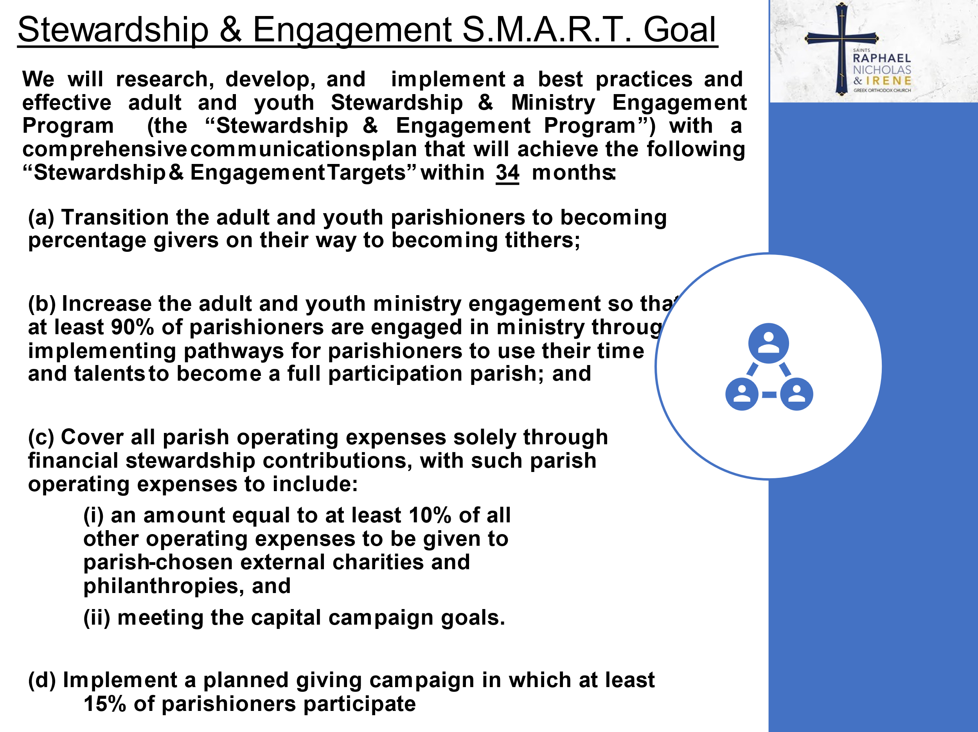
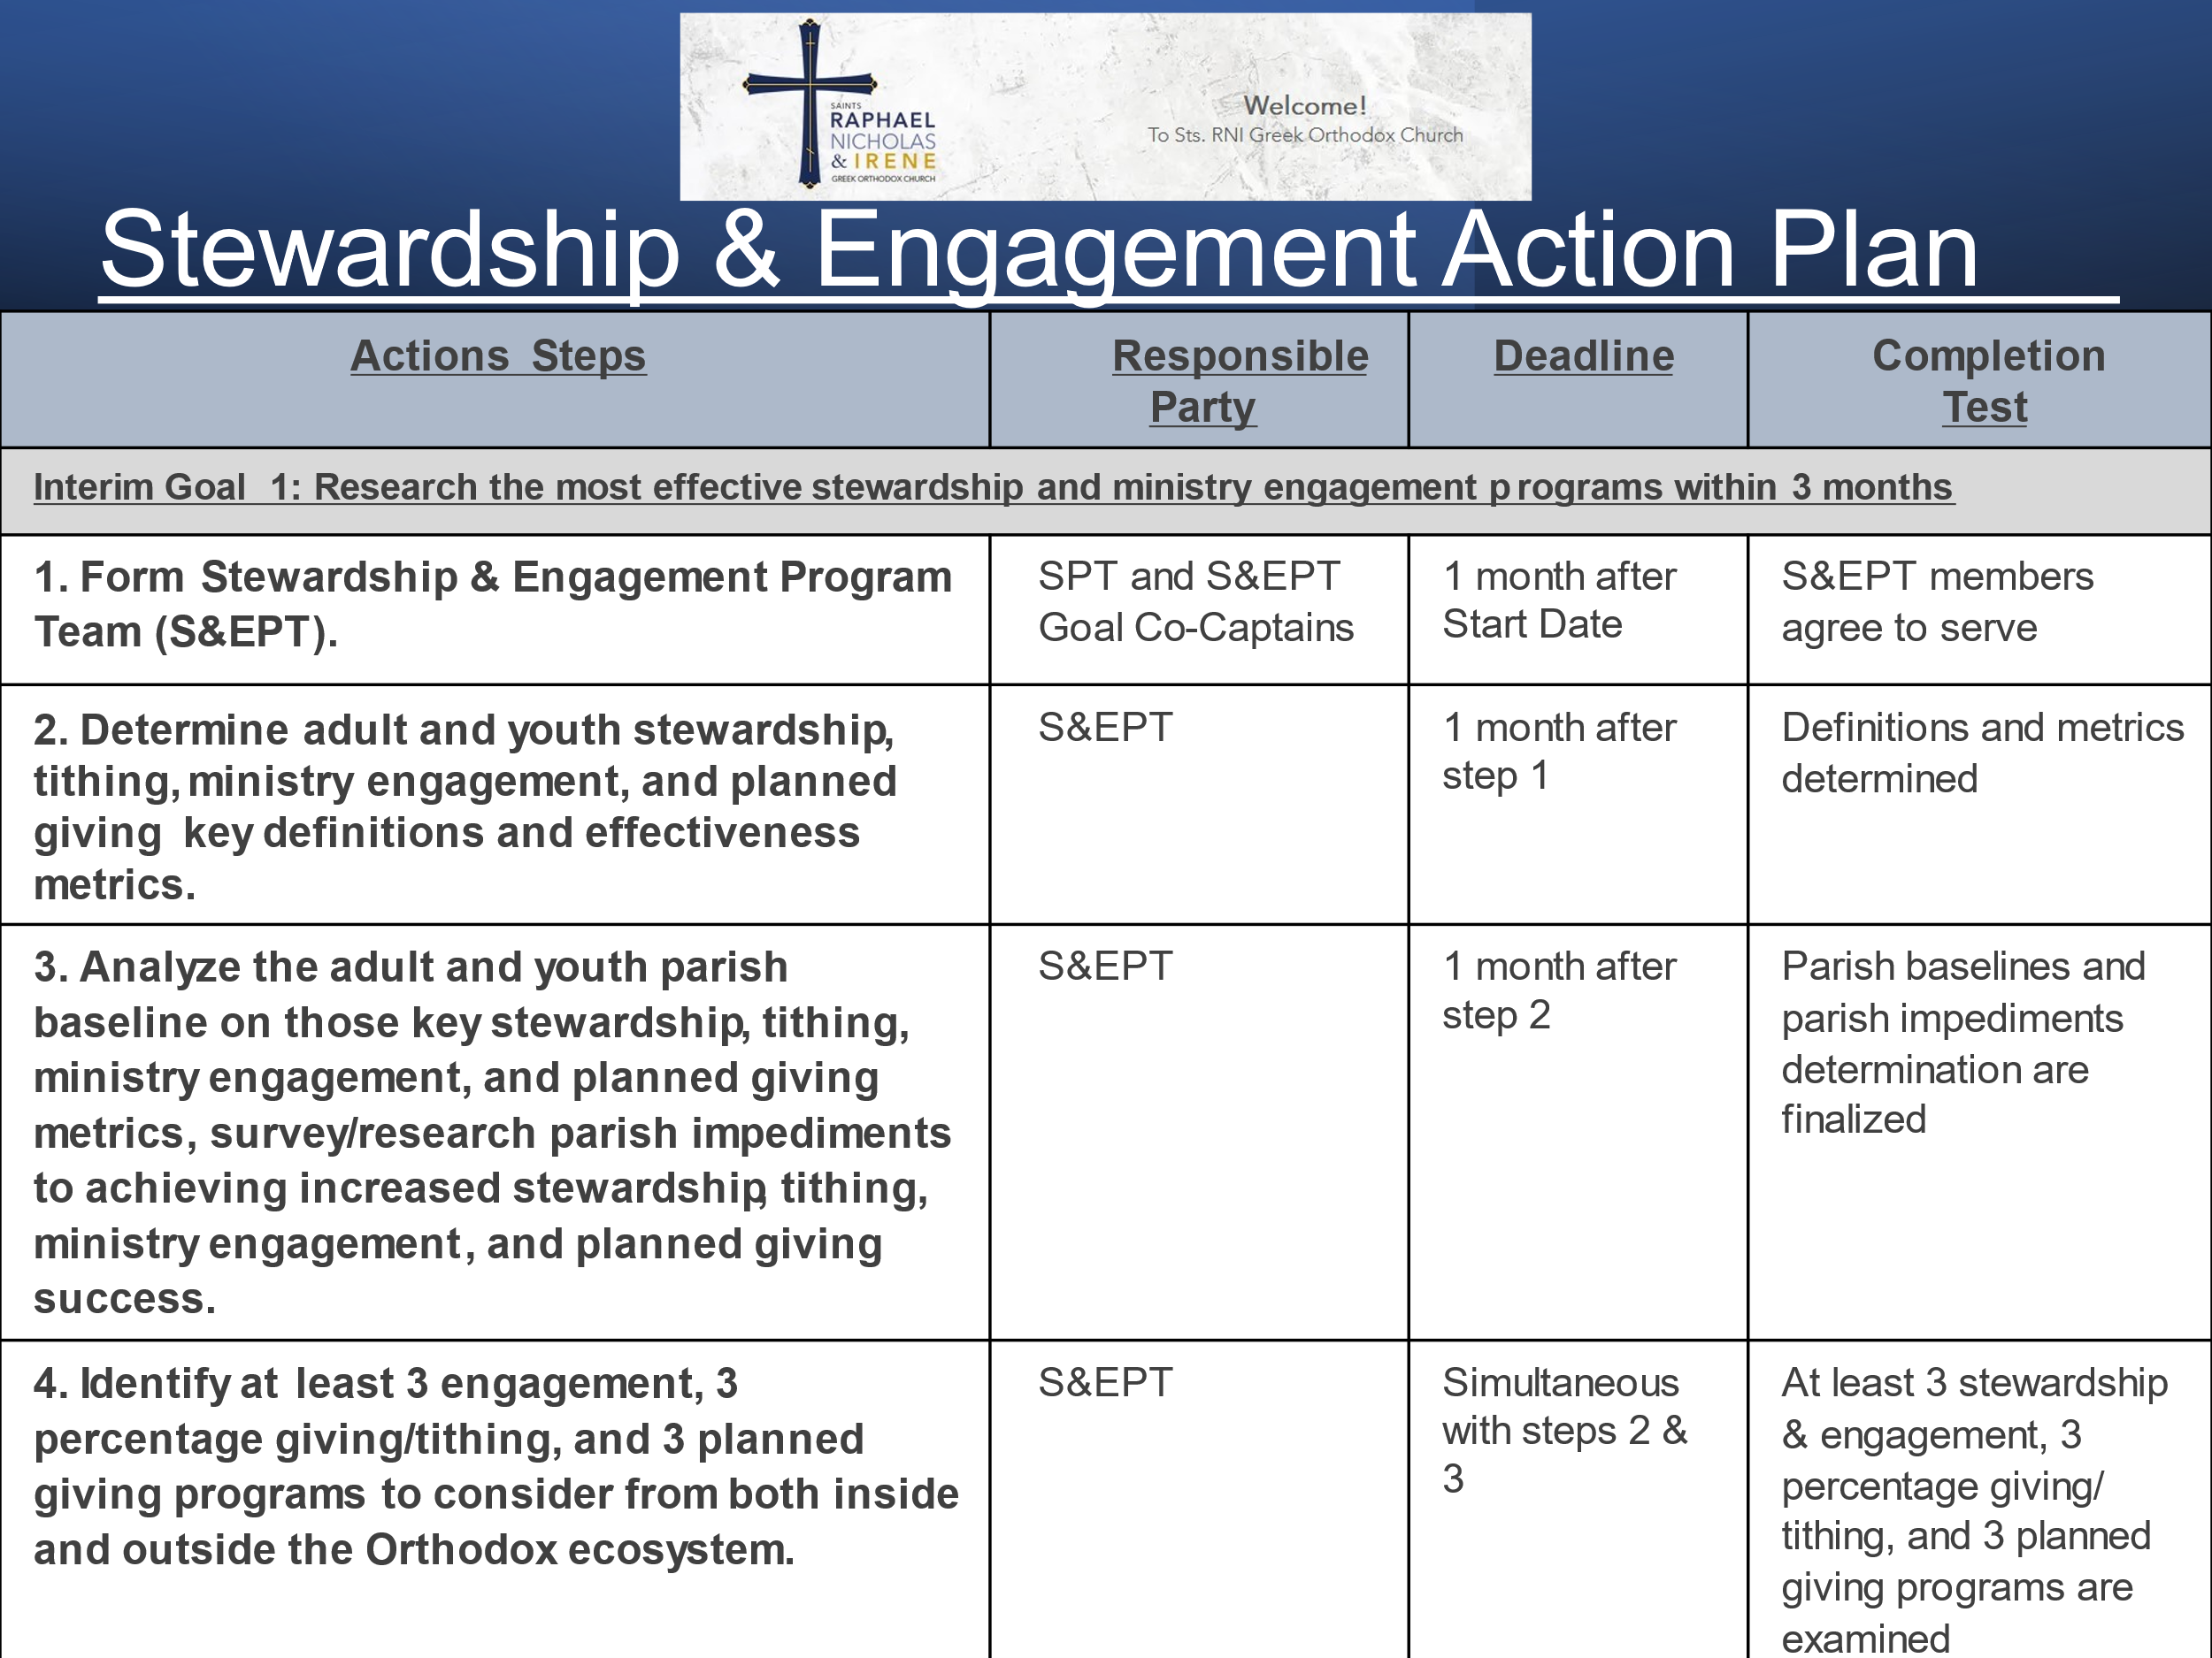
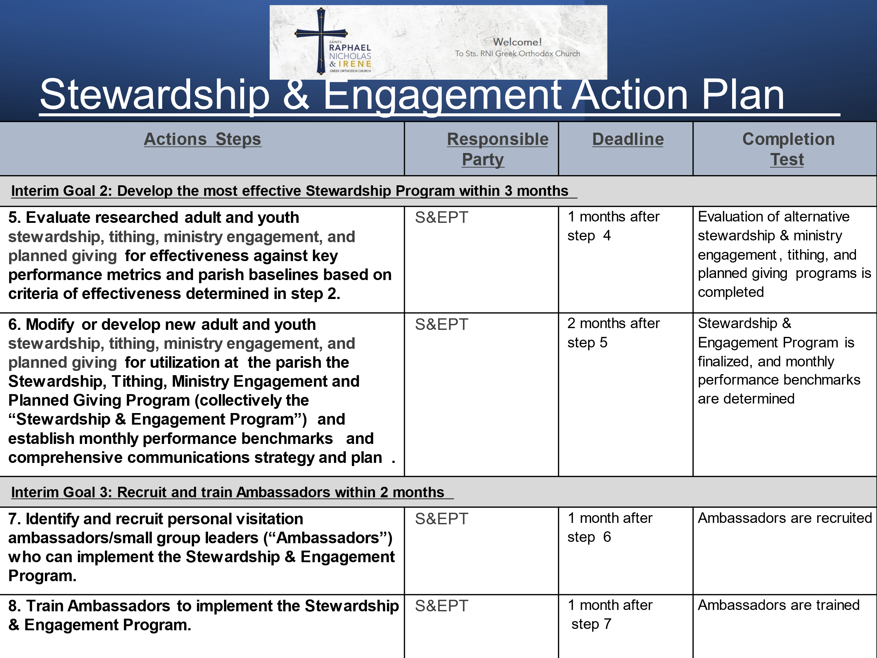
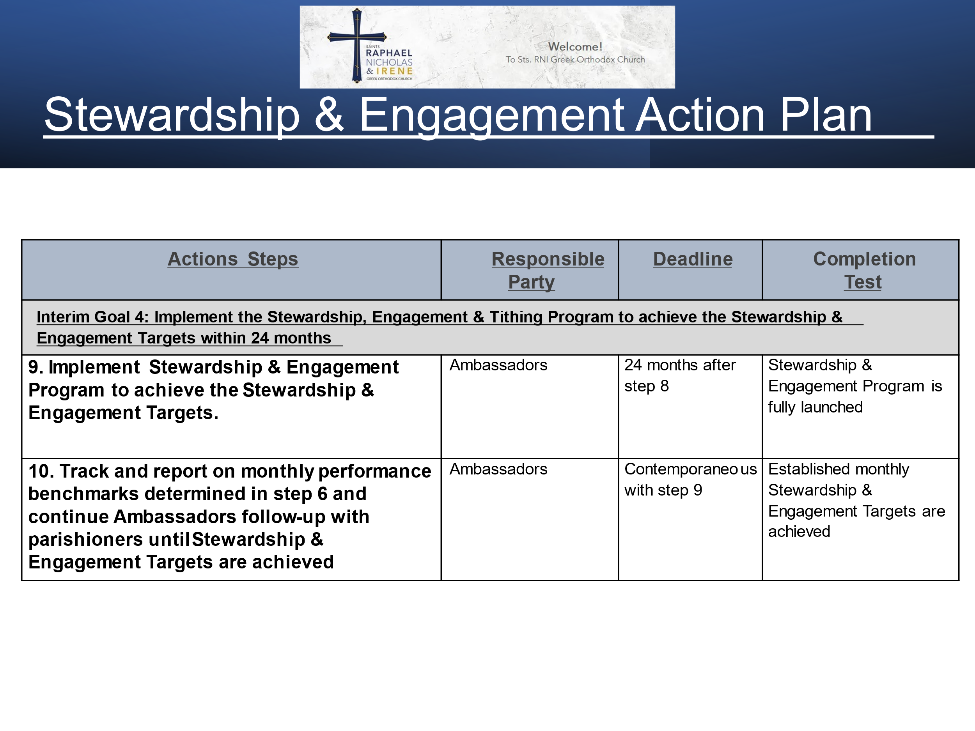

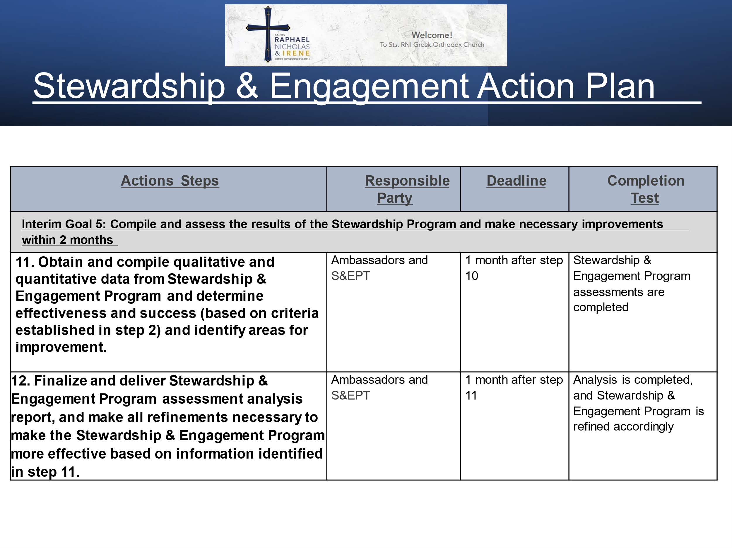
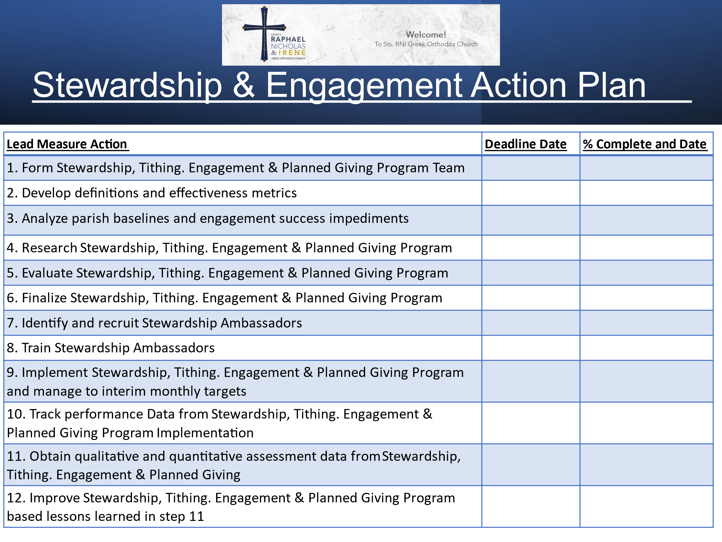

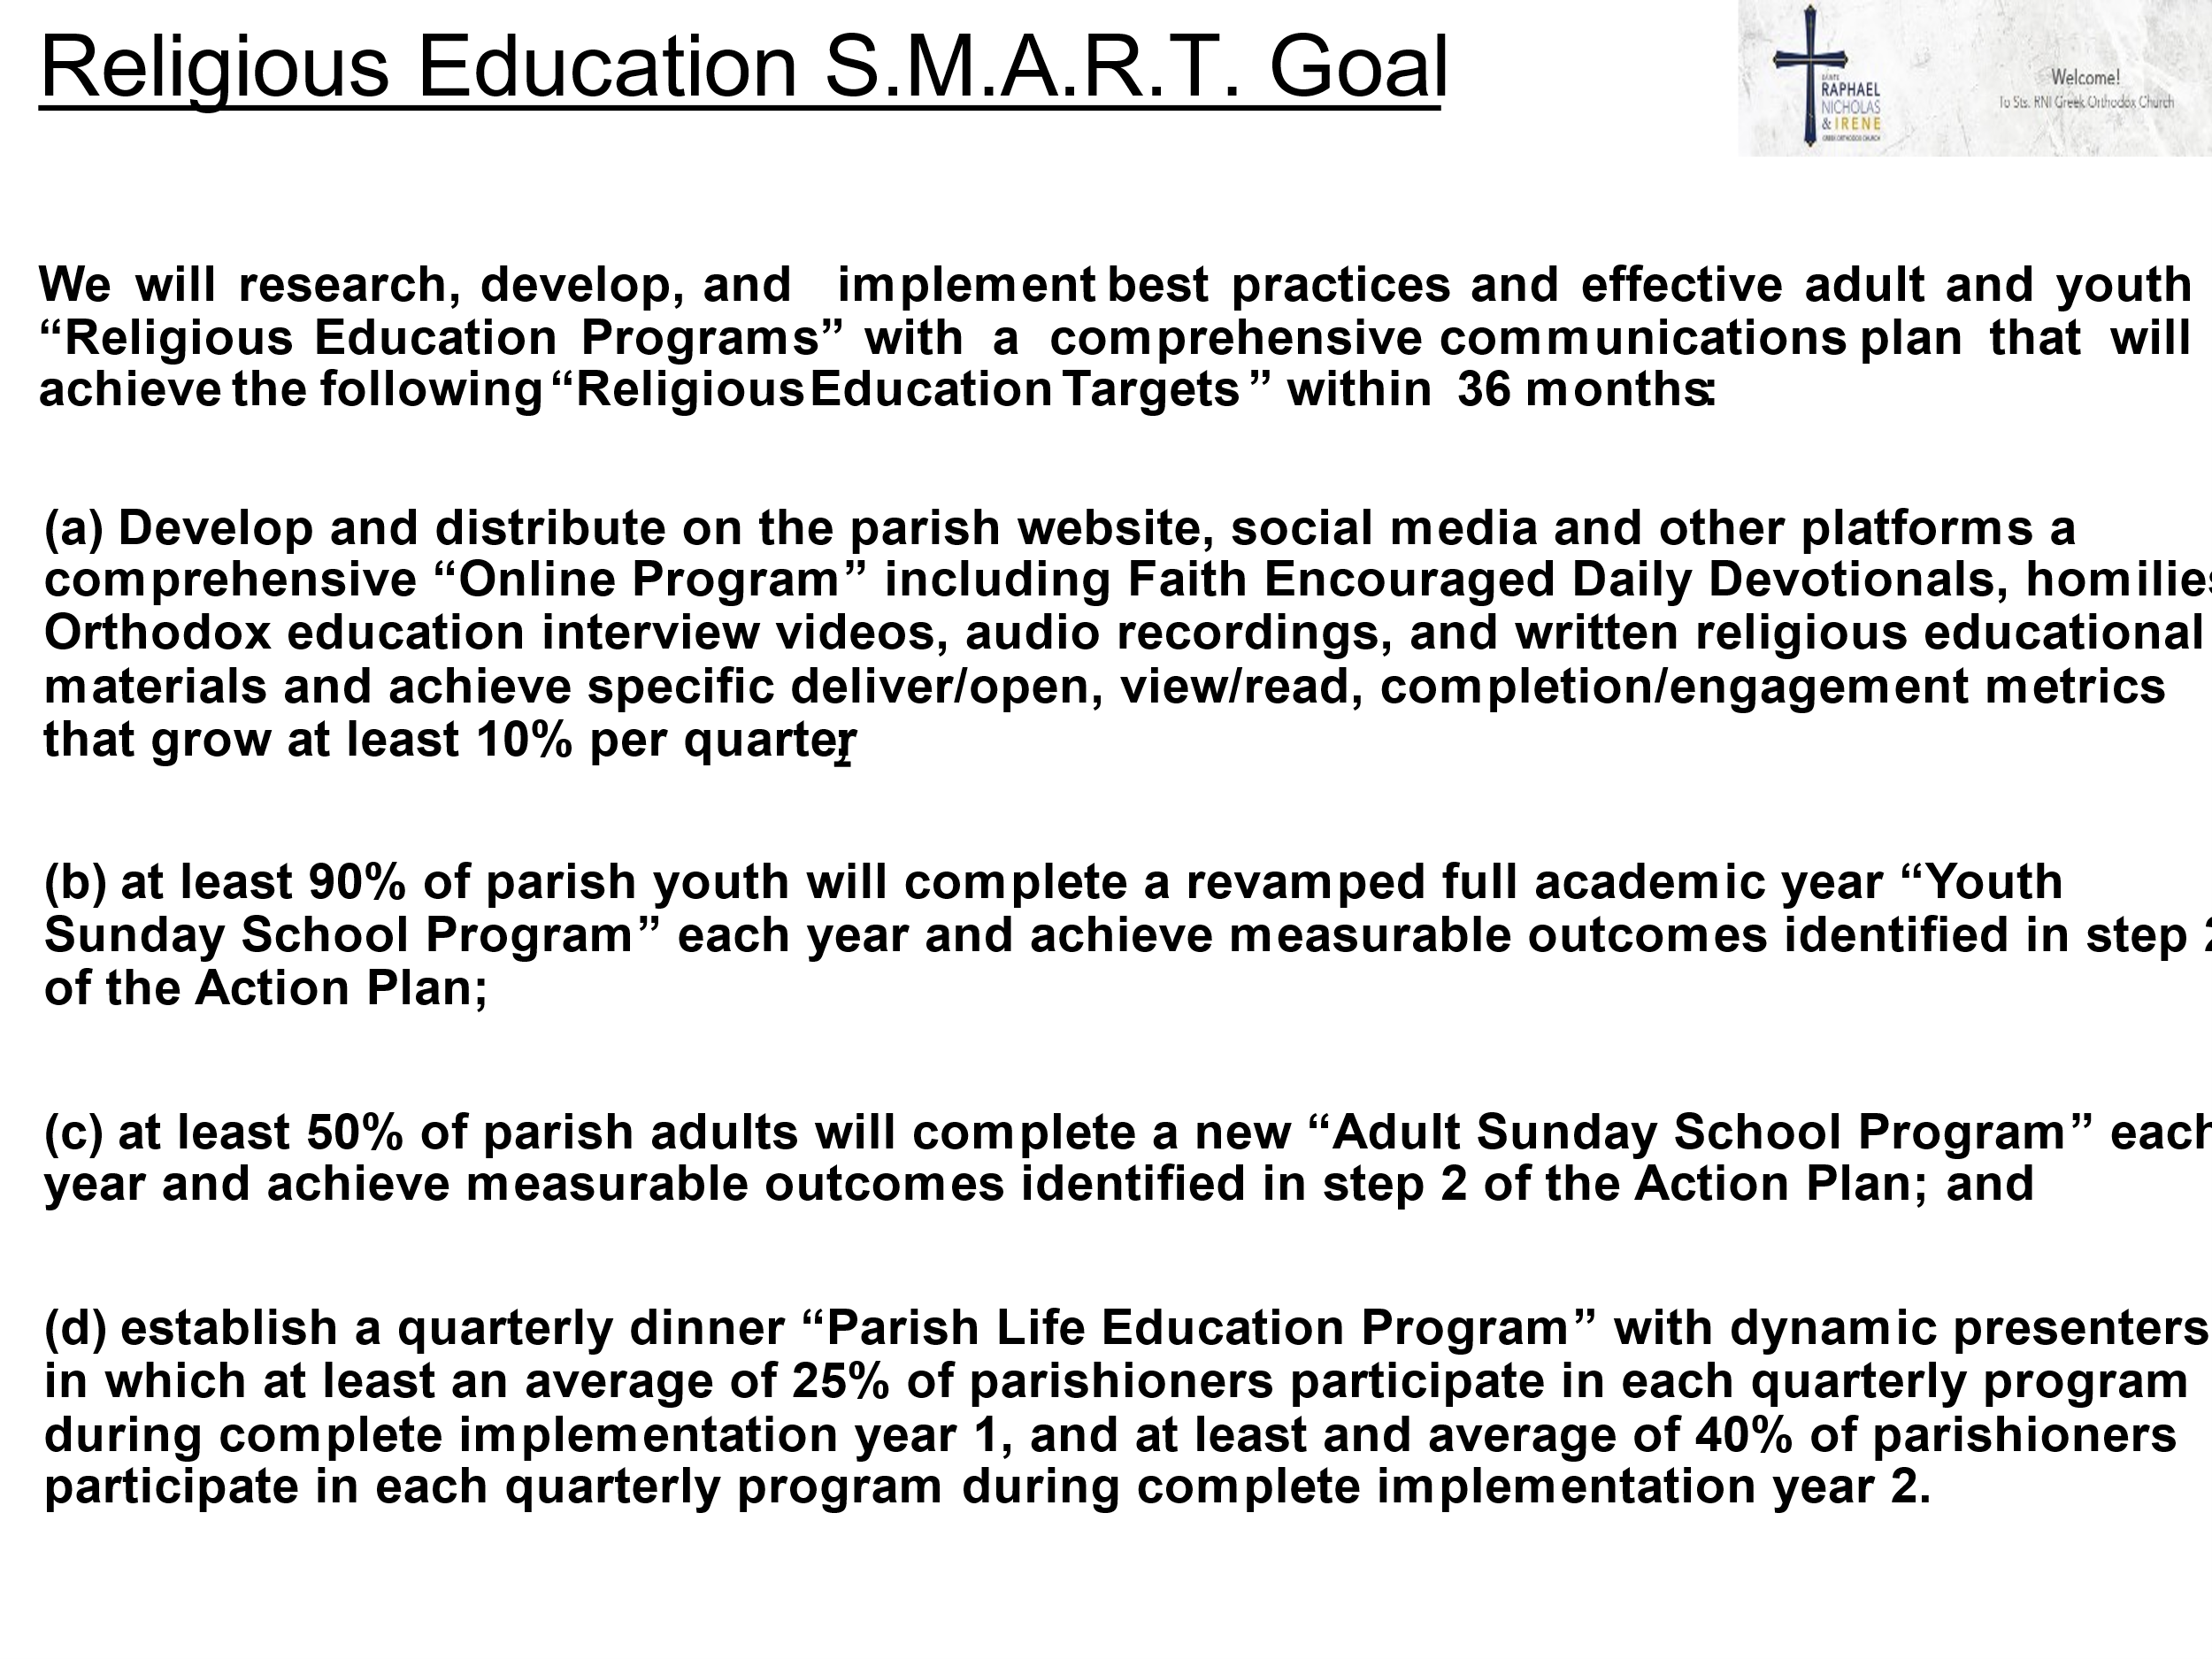
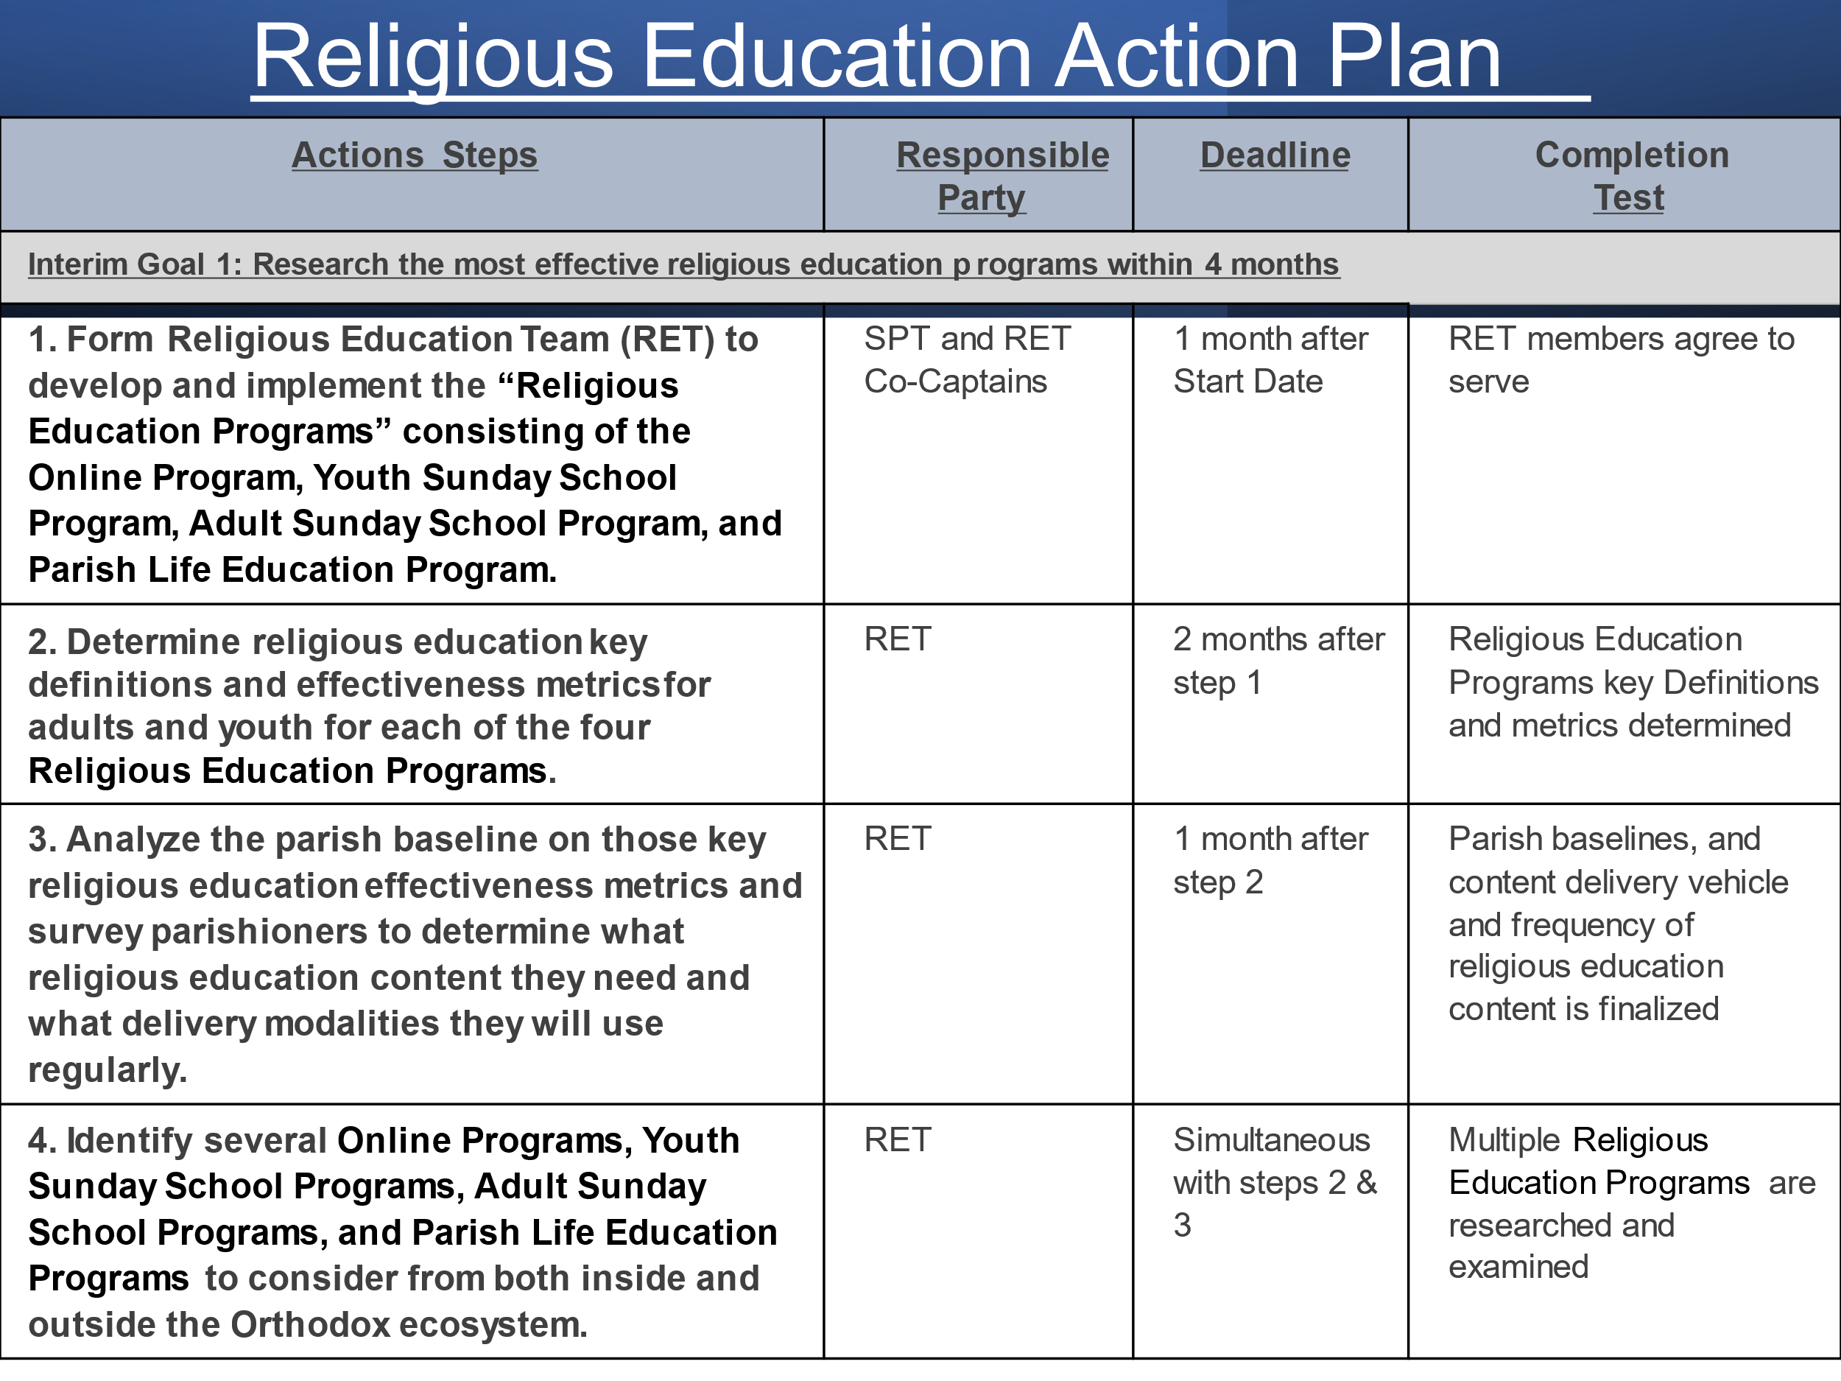
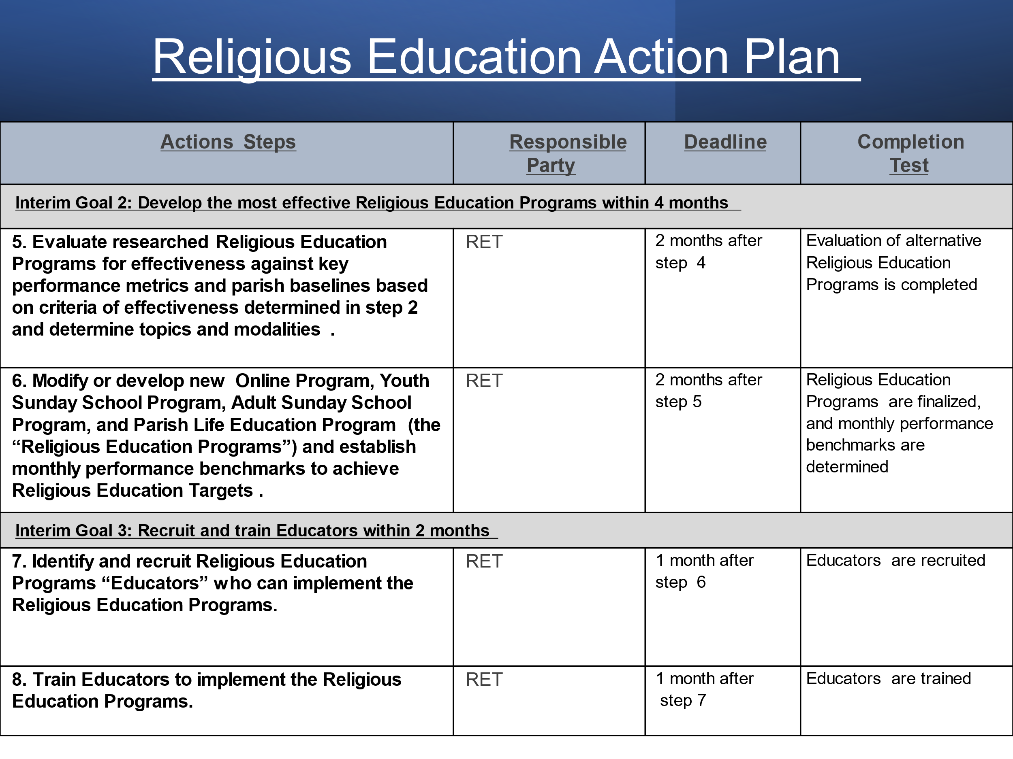
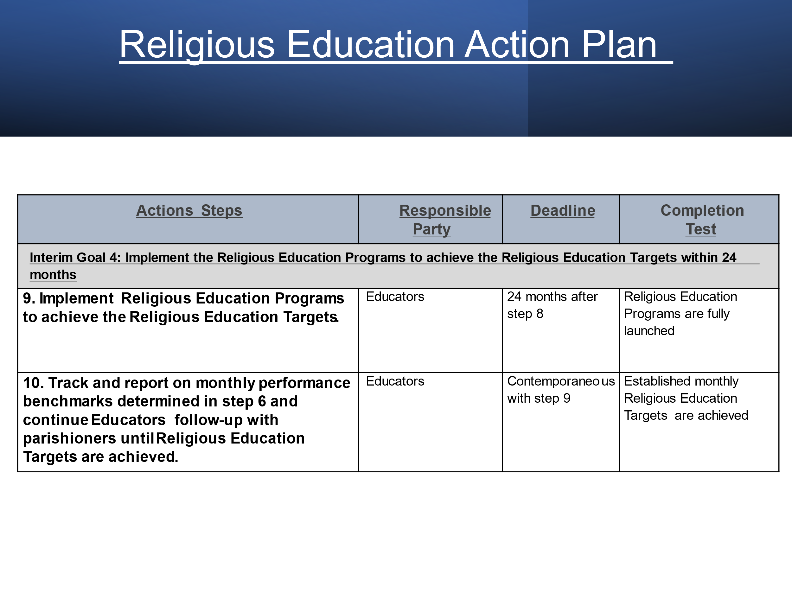

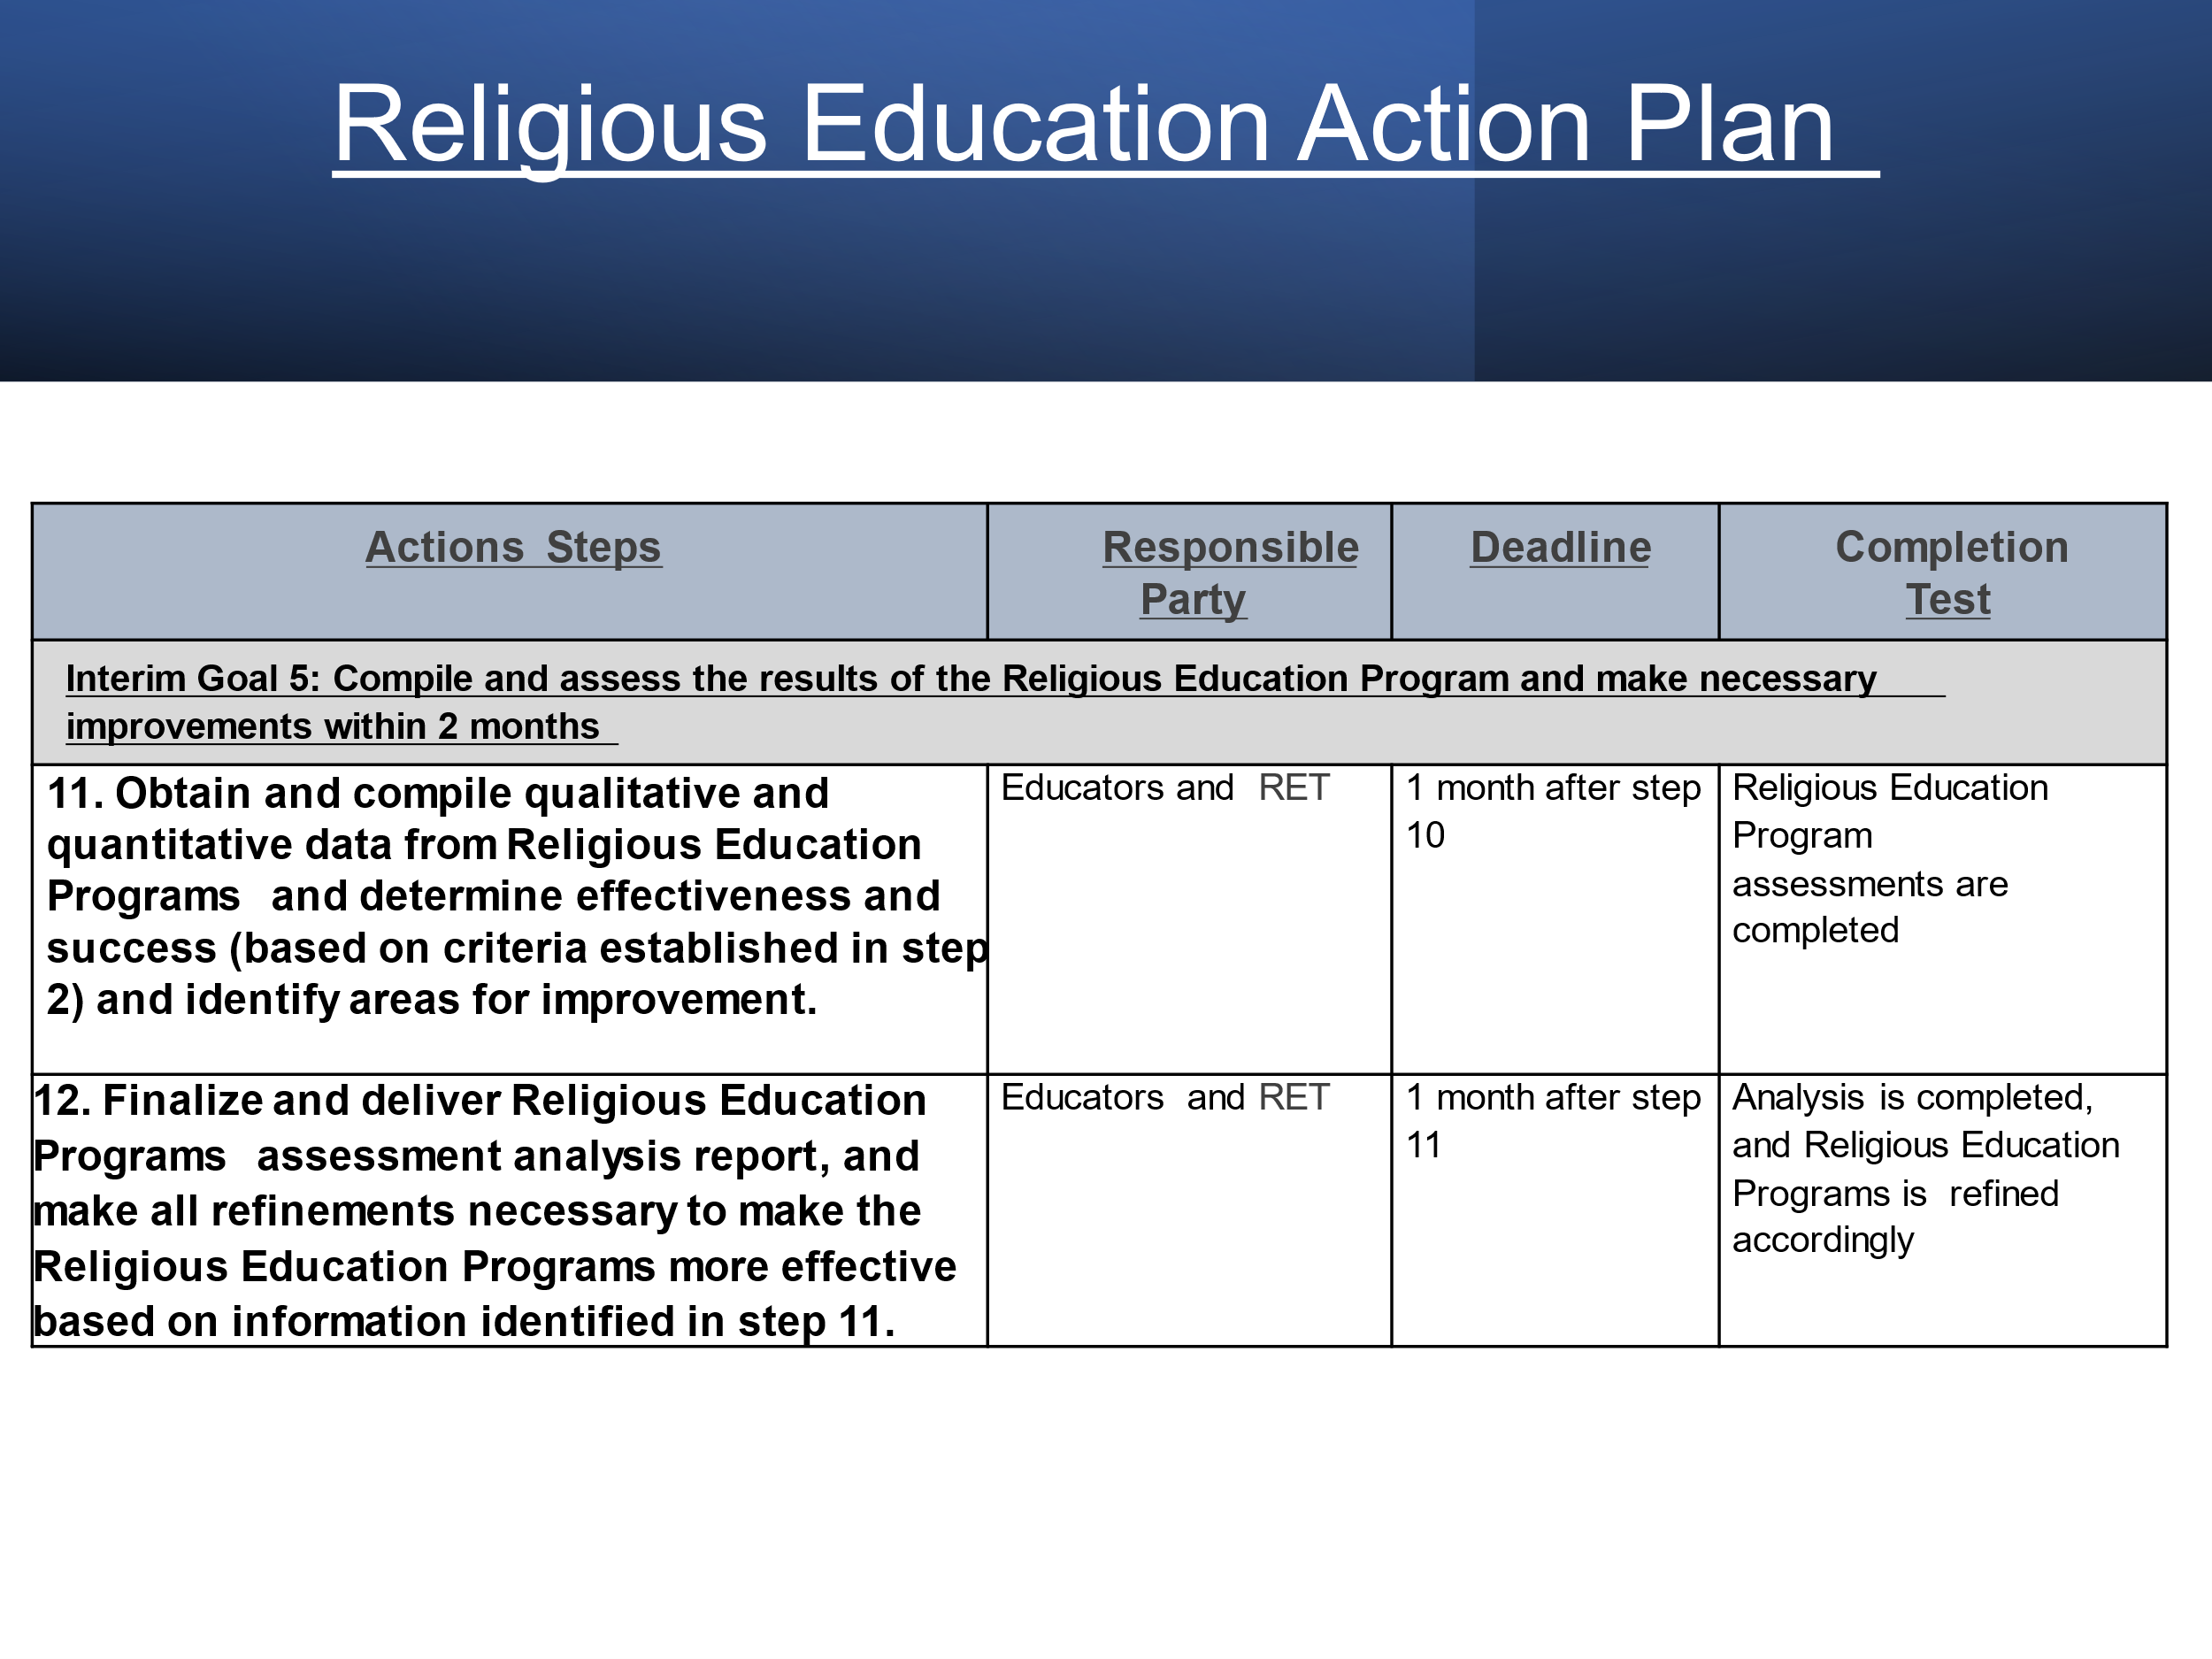
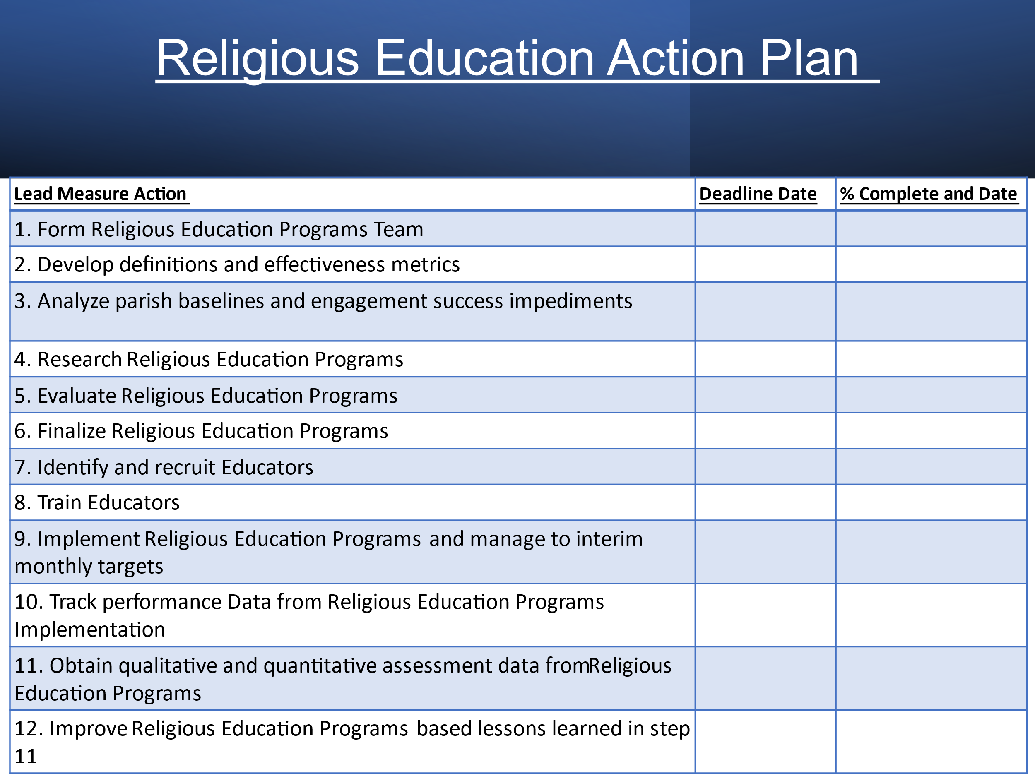
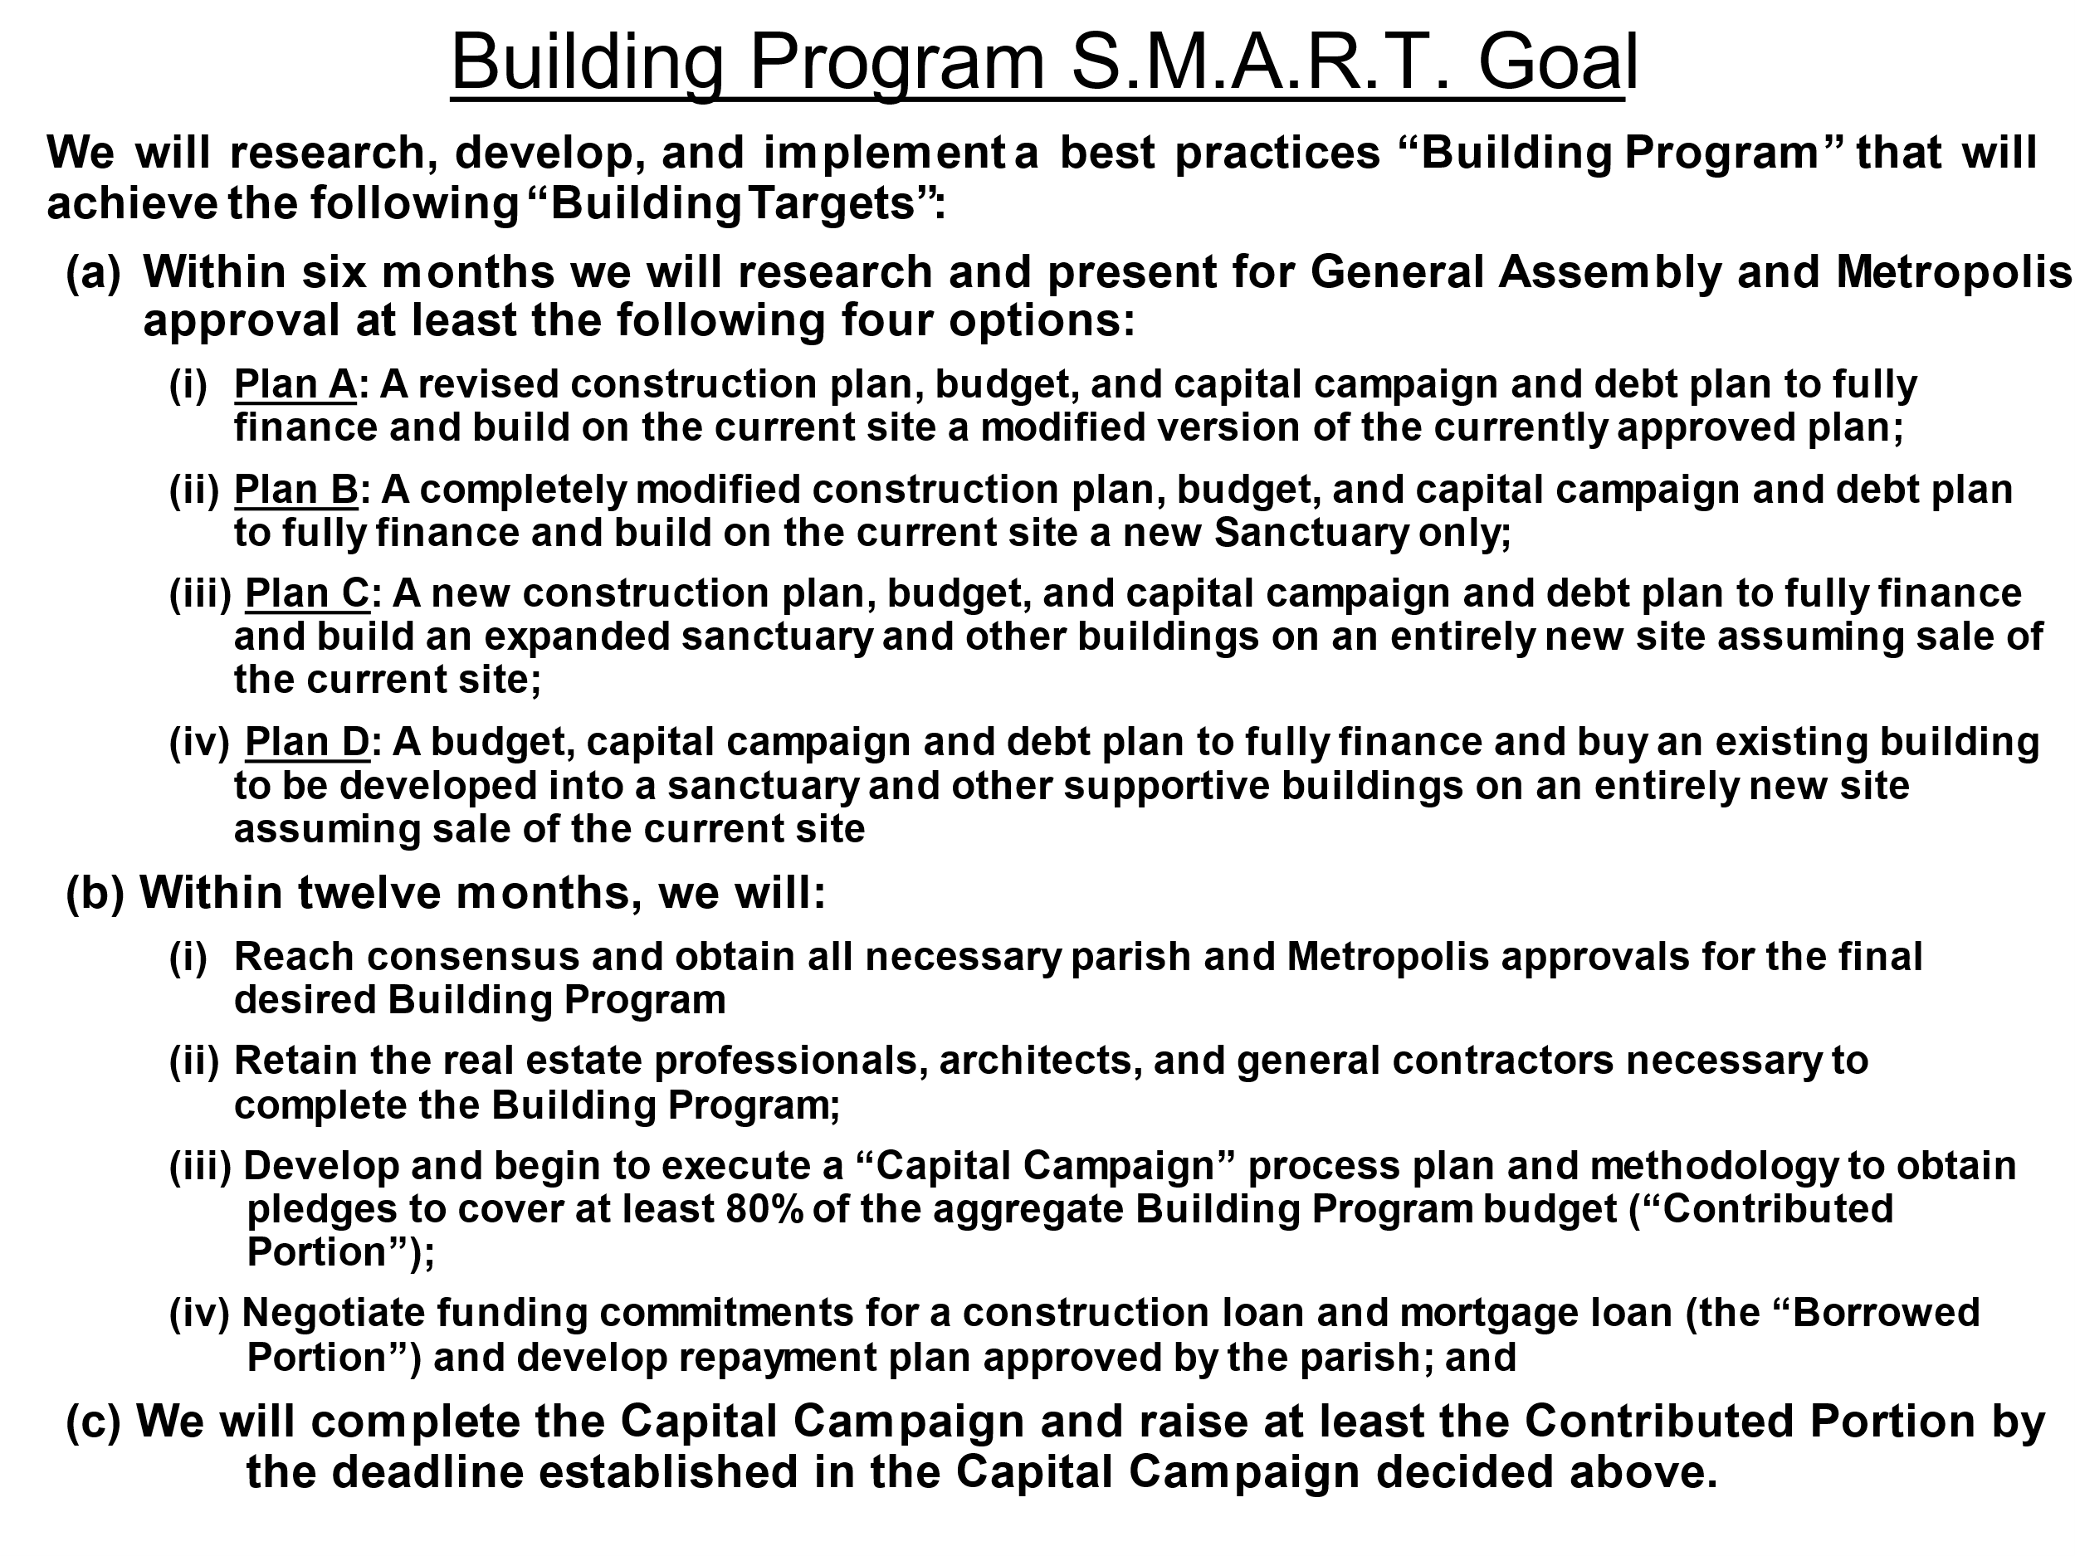

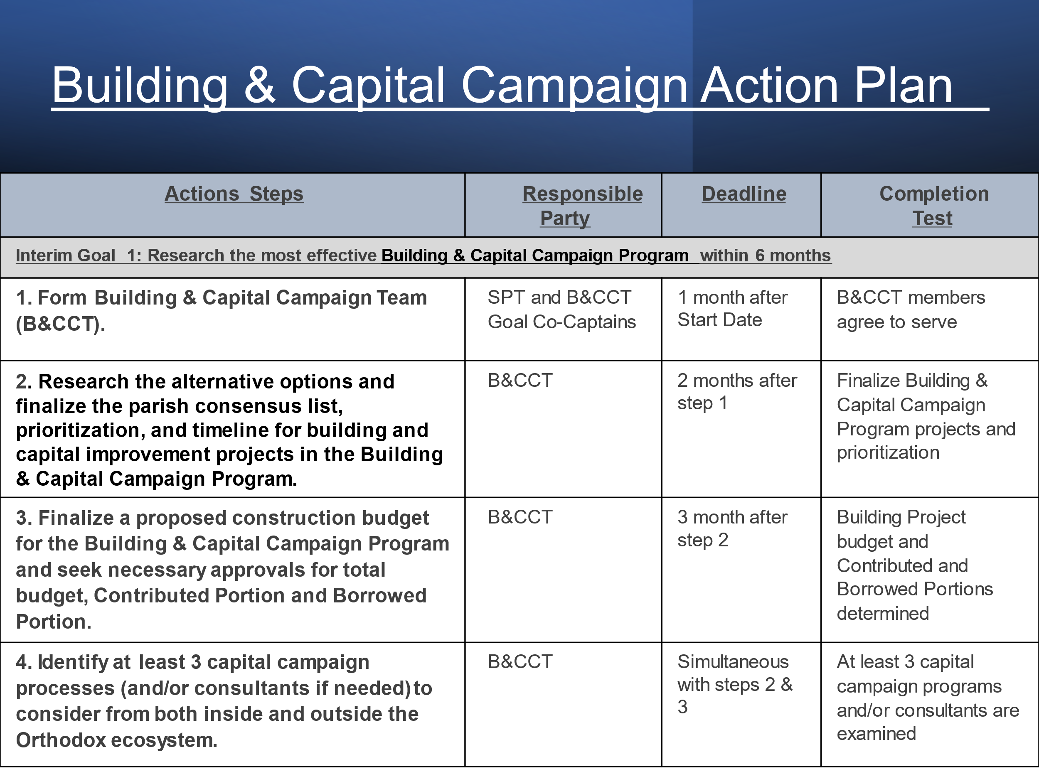
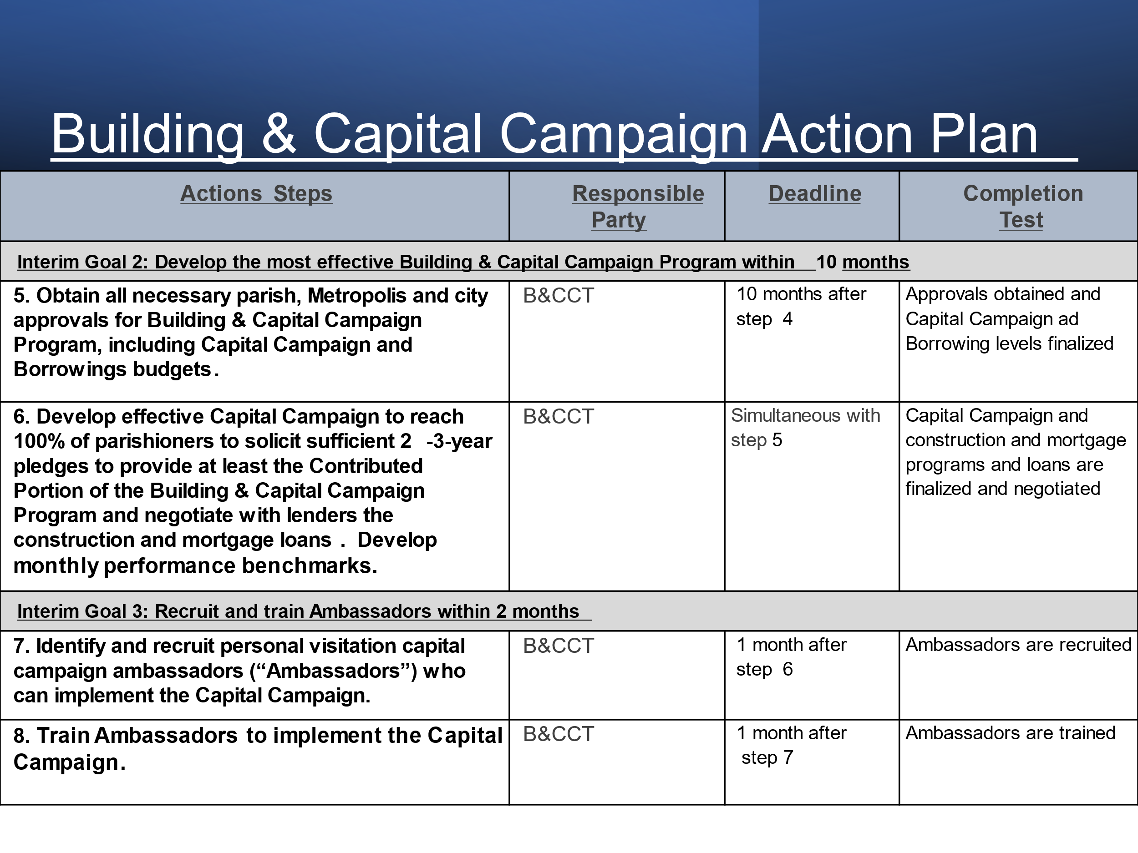
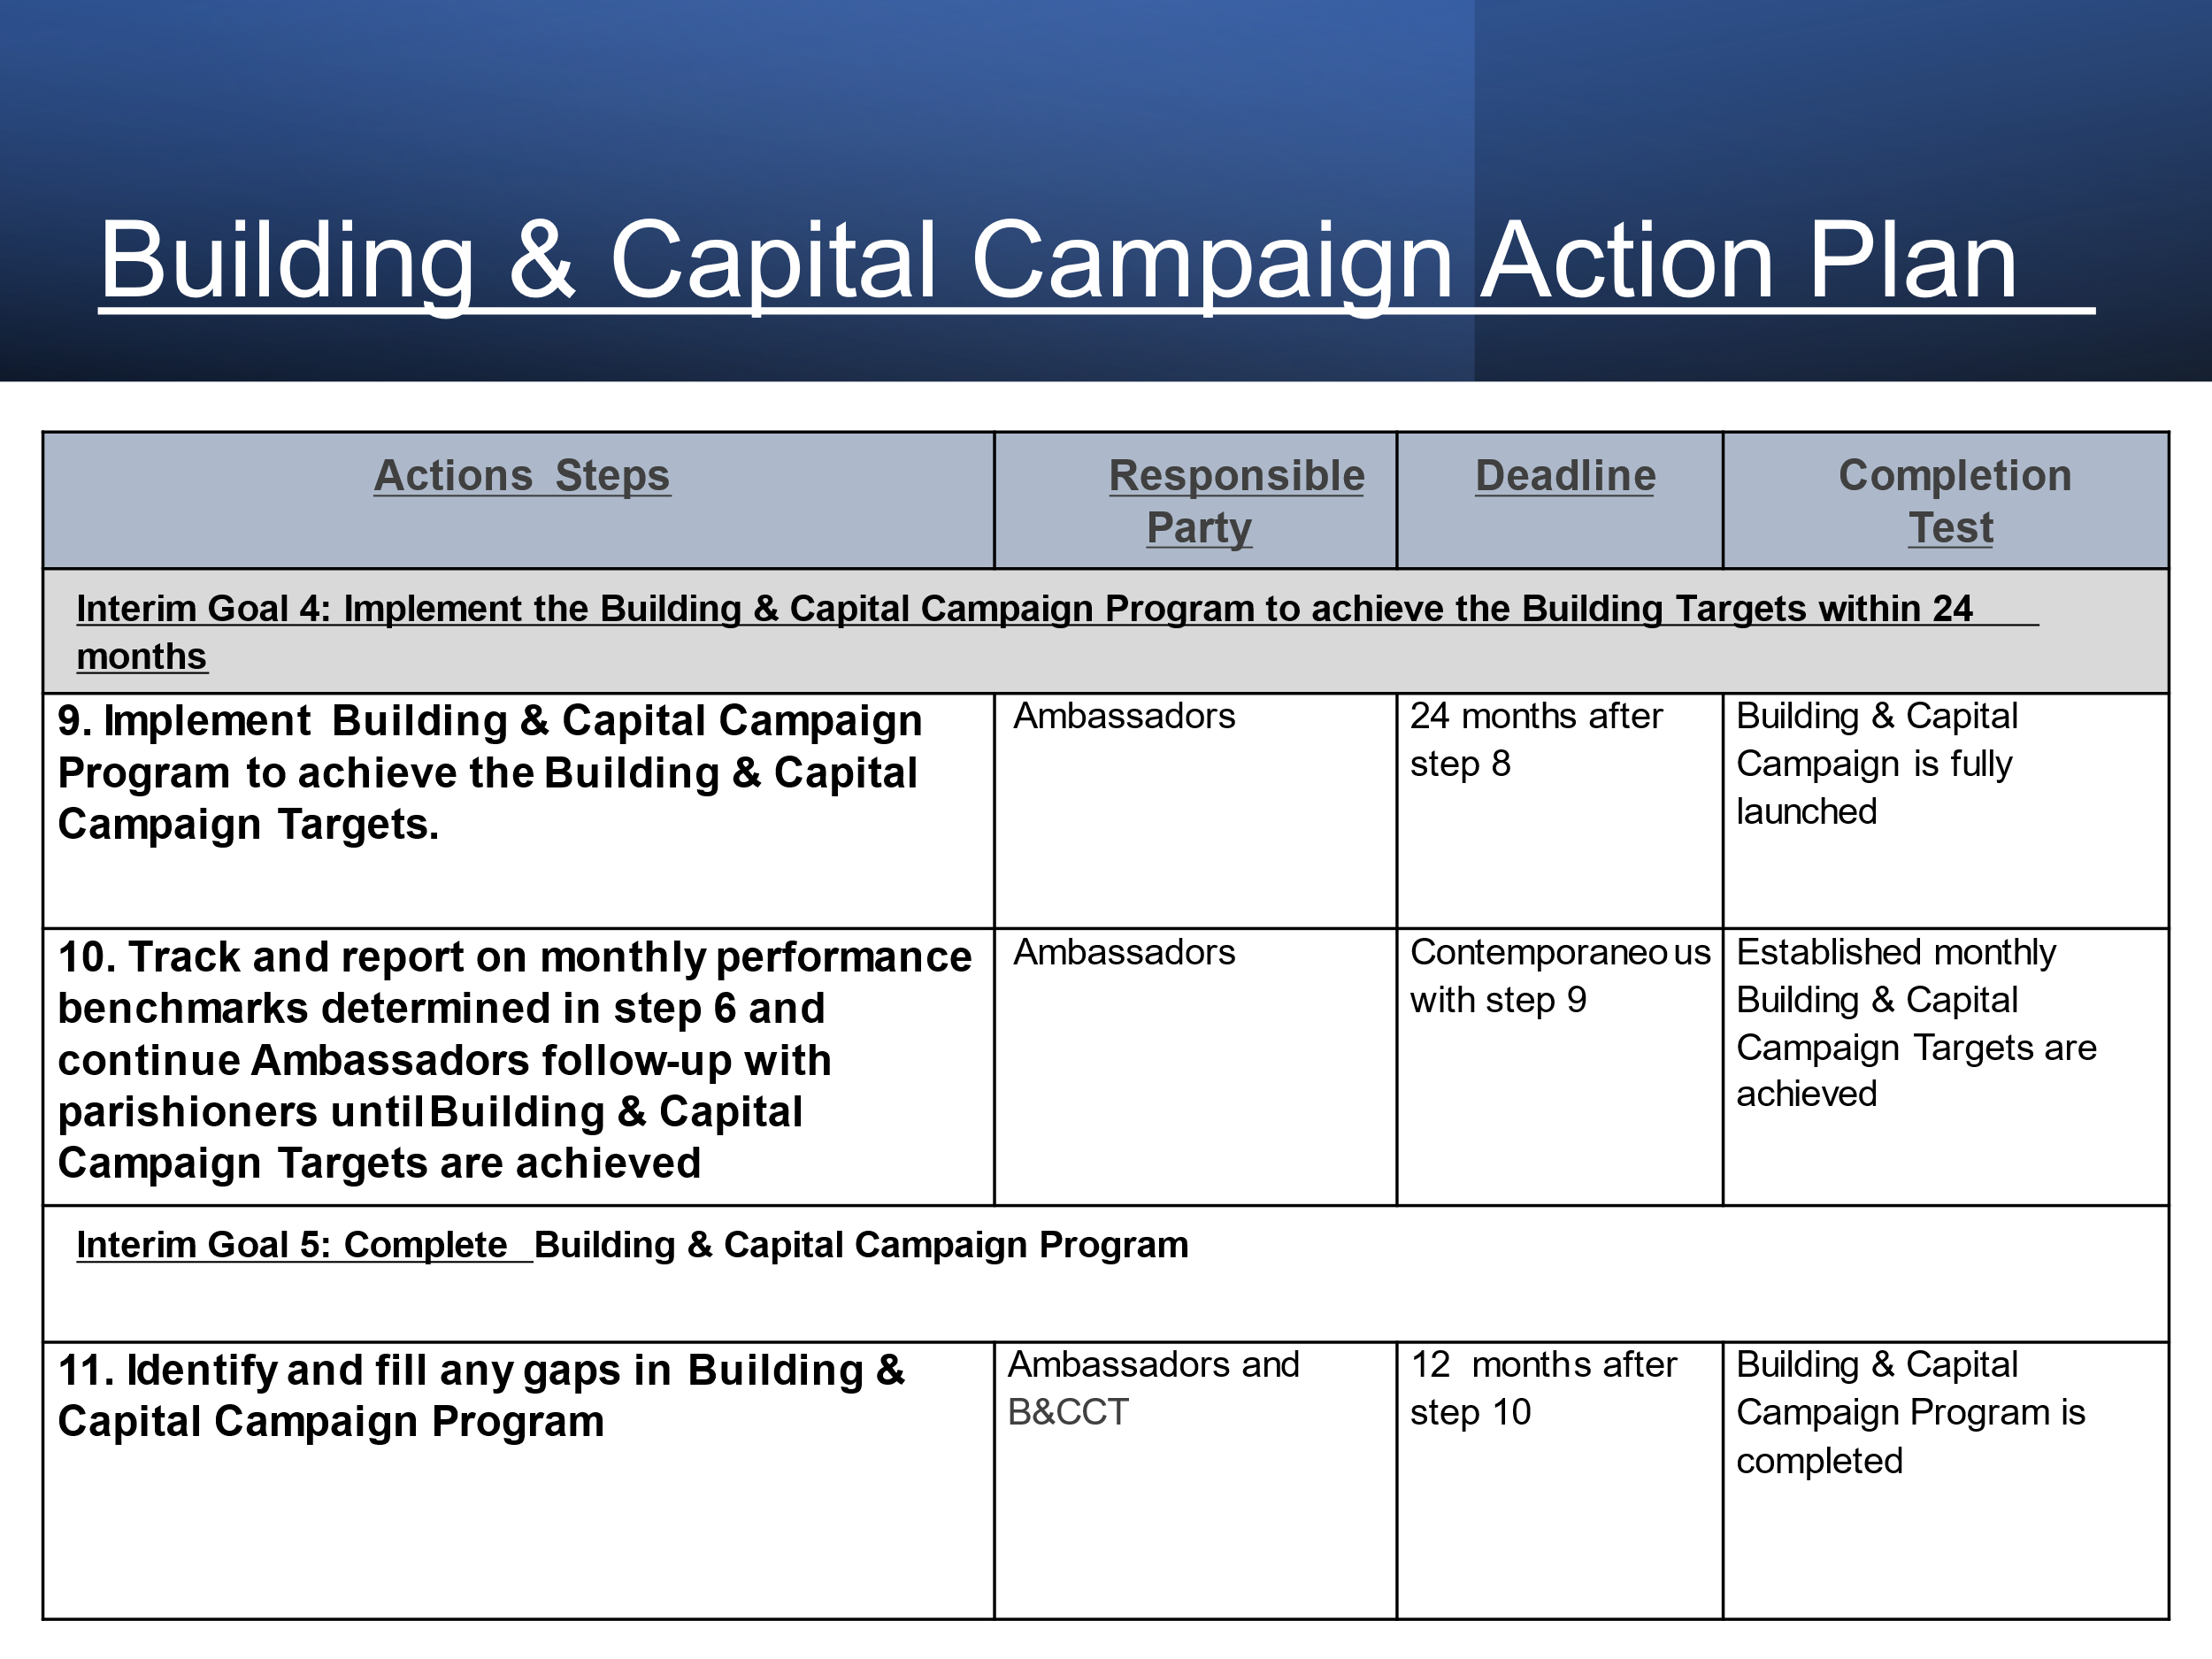

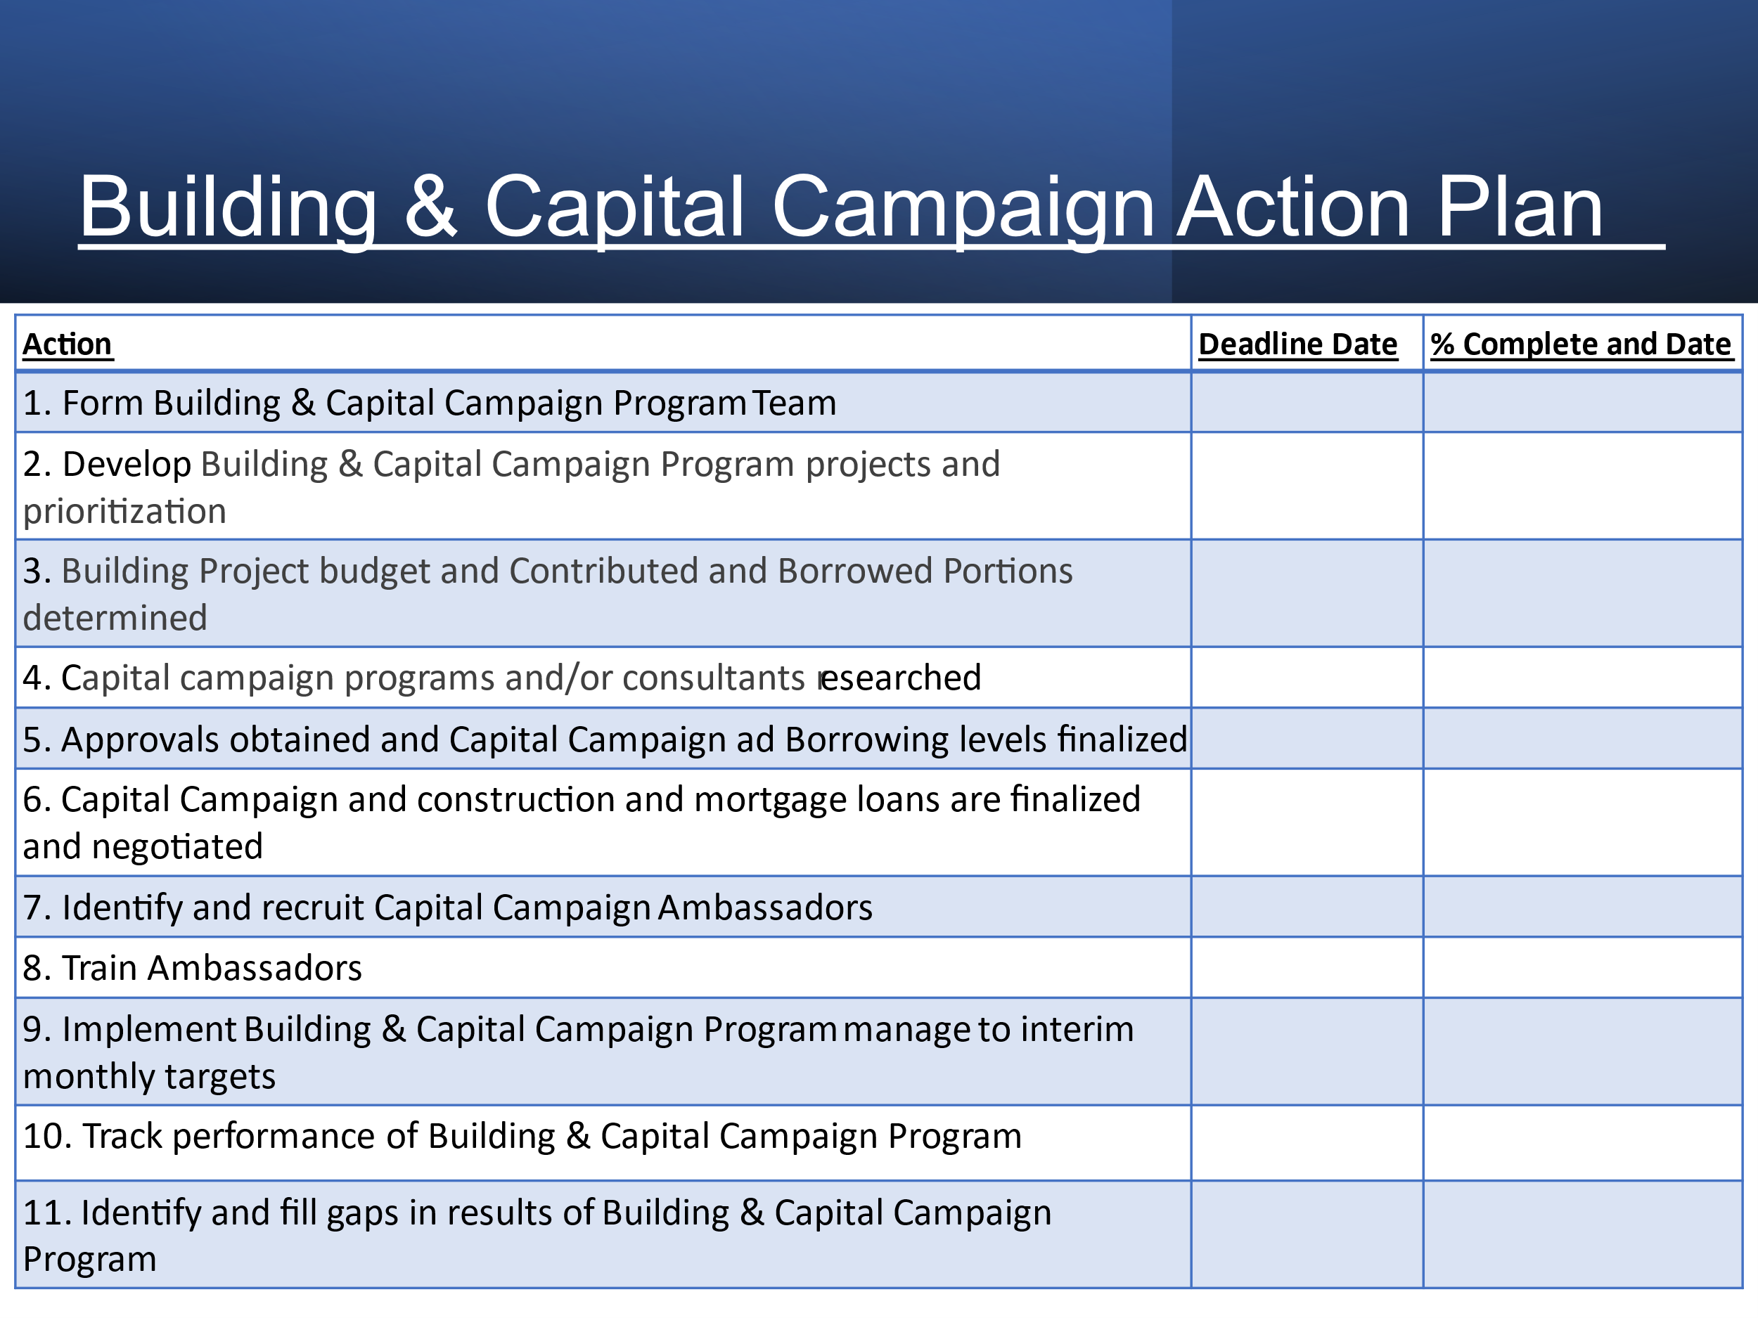

ENDNOTES

II Corinthians 5:10
See Simon Sinek, Start With Why - How Great Leaders Inspire Everyone To Take Action. @Ted.com
This is a slightly modified expression of belief offered by famed author and philosopher Mark Twain
Acts 14:15
John 1:46
Matthew 28:19-20
St Athanasius Academy of Orthodox Theology, The Orthodox Study Bible, (United States: St. Athanasius Academy Septuagint, 2008), 1468
Acts 1:8
The Strategic Planning Team (“Strategic Planning Team”) was led by our clergy, Fr. Barnabas, facilitated by Bill Marianes and consisted of the following faithful and hard-working members (in alphabetical order: Last Name First Name Chapman David Conner Mike Costakis-Hayes Ann Crosio Stephanie DiGennaro Ioanna DiGennaro Tim Donkar George Harper Jesse Harper Lee Heddings Joshua Heddings Jessica Johnson Nichole Kemp Evelyn Lucher Lynne Nease Sy Nease Mary Panos Alex Pappas George Porter Nancy Powell Fr. Barnabas Theofilis Barbara Theofilis Alexander Tzevelekos Greg Waldron Rusty The Strategic Planning Team and its Facilitator devoted many hundreds of hours of work over many months to do the work to develop this Strategic Plan. The volunteer Strategic Planning Team members thank God for our many blessings, and we are thankful for the opportunity to be stewards of Christ’s church and this Parish. The Implementation Teams formed to achieve this Strategic Plan will include the Strategic Planning Team and many more individuals who will volunteer to lead and work on our 3 Strategic Goals. We humbly and respectfully thank all our co-workers in advance for their dedication and stewardship.
Matthew 28:19
2 Corinthians 13:5
Matthew 5:1-16
Proverbs 29:18
Matthew 5:16
Matthew 10:1, 5-8
1 Corinthians 12:28
Luke 10:1

